Appendix Files

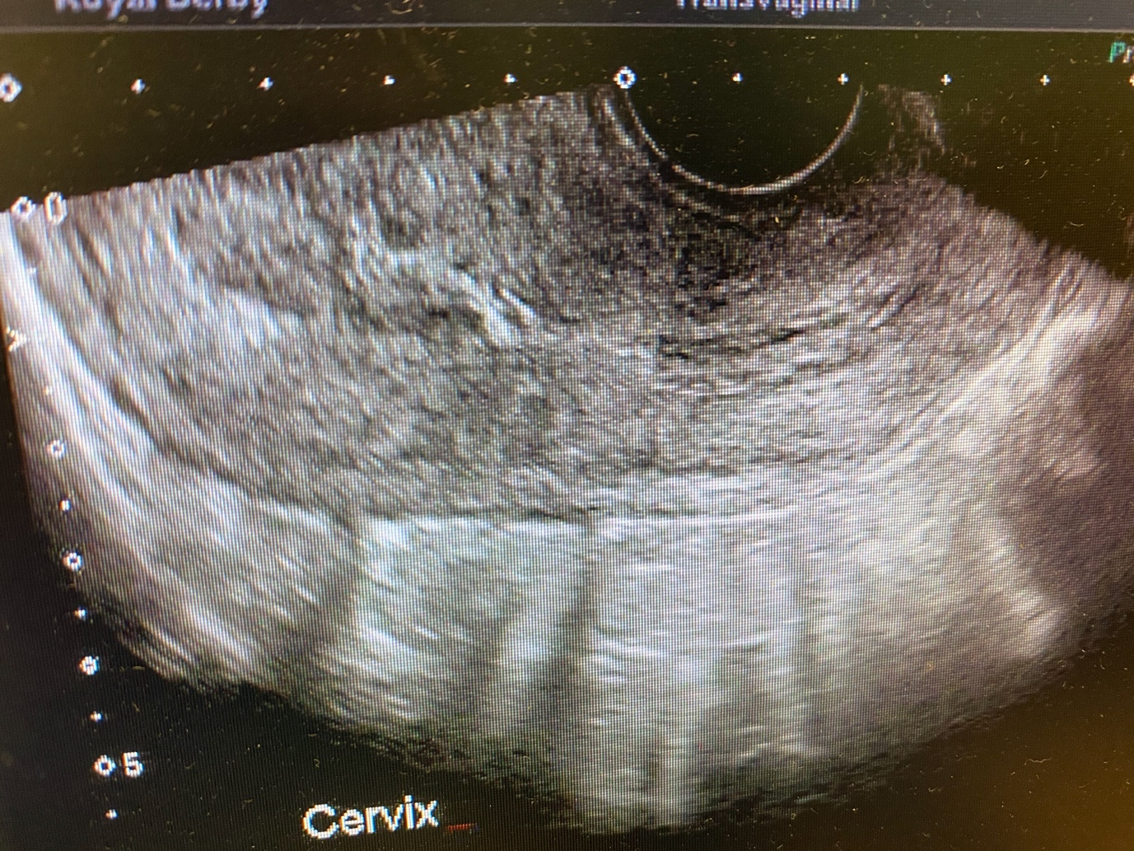
Appendix 1: USS.

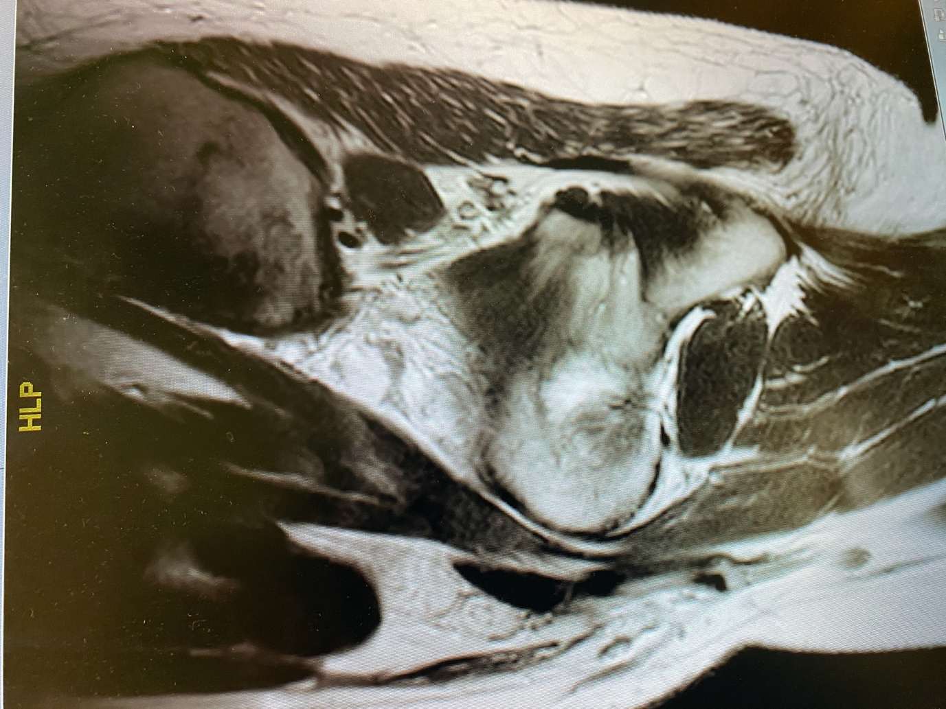
Appendix 2: MRI.

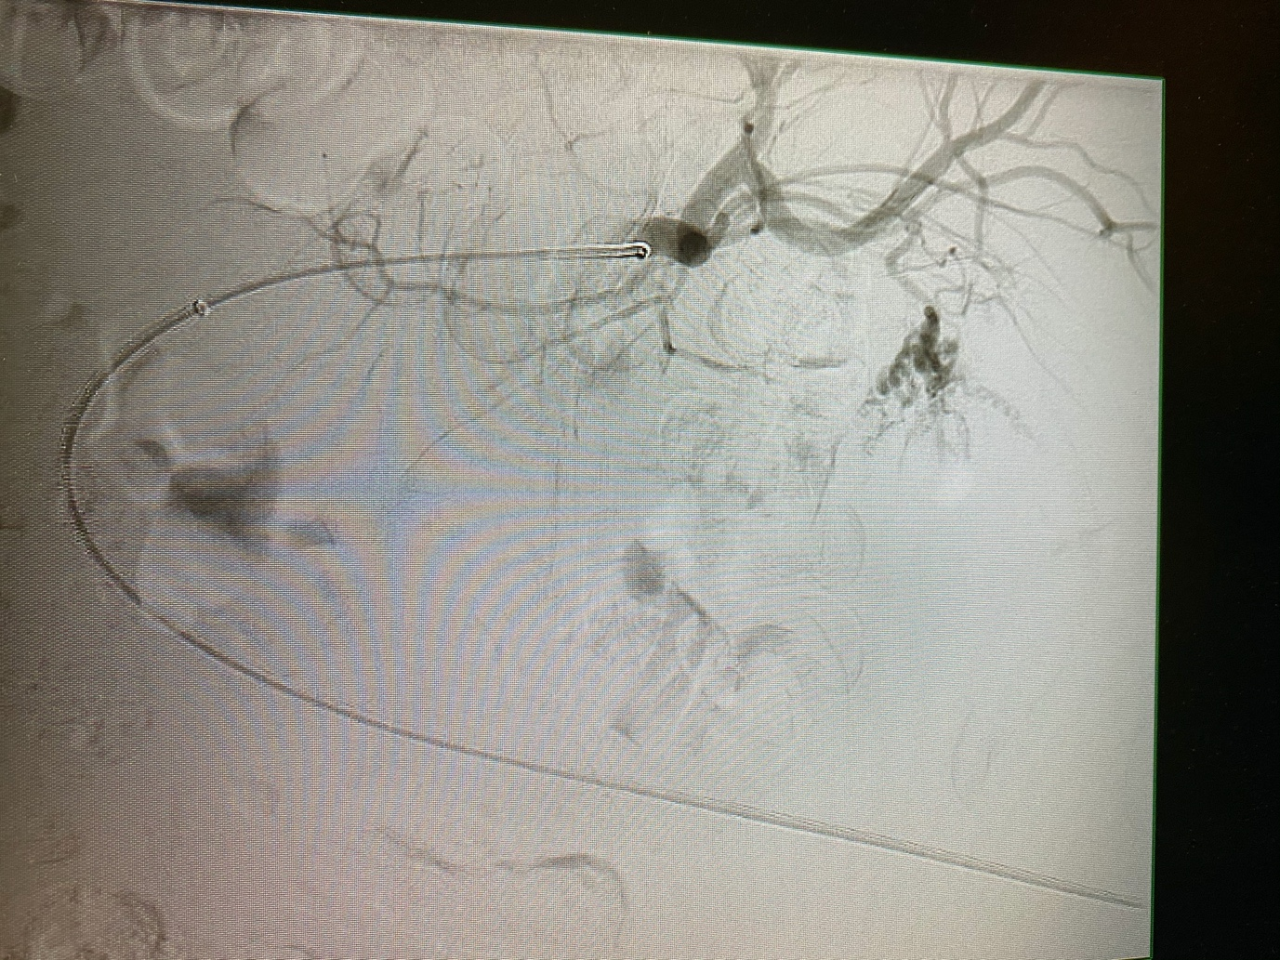
Appendix 3A: Angiograph.
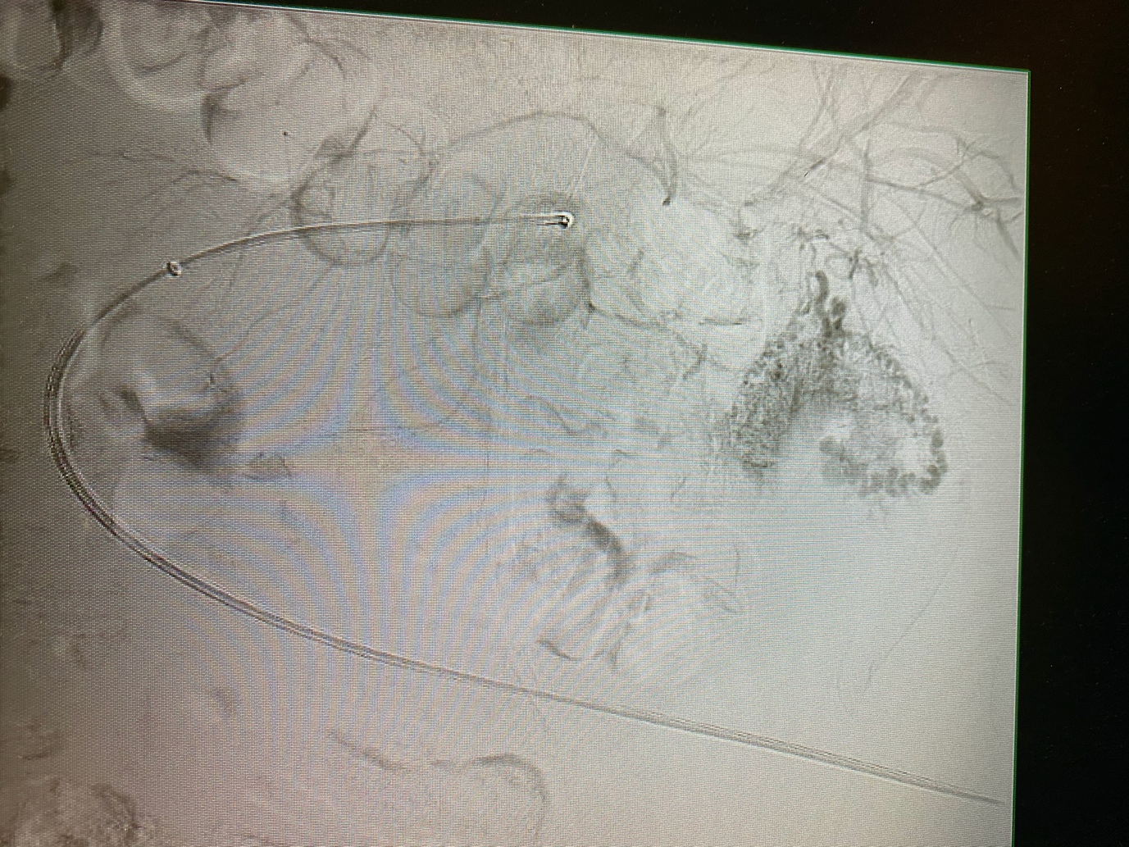
Appendix 3B: Angiogram.

