Appendix: Exercise chart for the patients intended for home therapy.
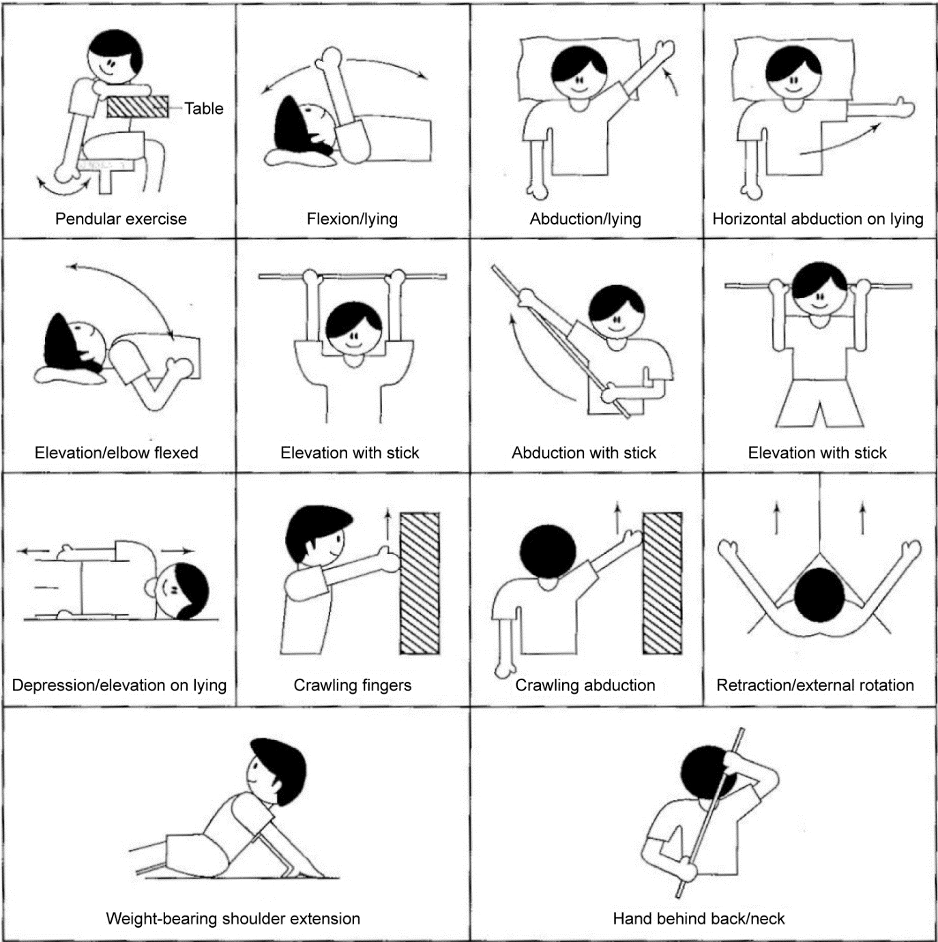
Instructions: complete the exercise 2-3 times per day (morning, midday and evening), repeating each exercise 10 times each for 6 weeks.

