Analyse after the exclusion of patient died within 24 hours after admission
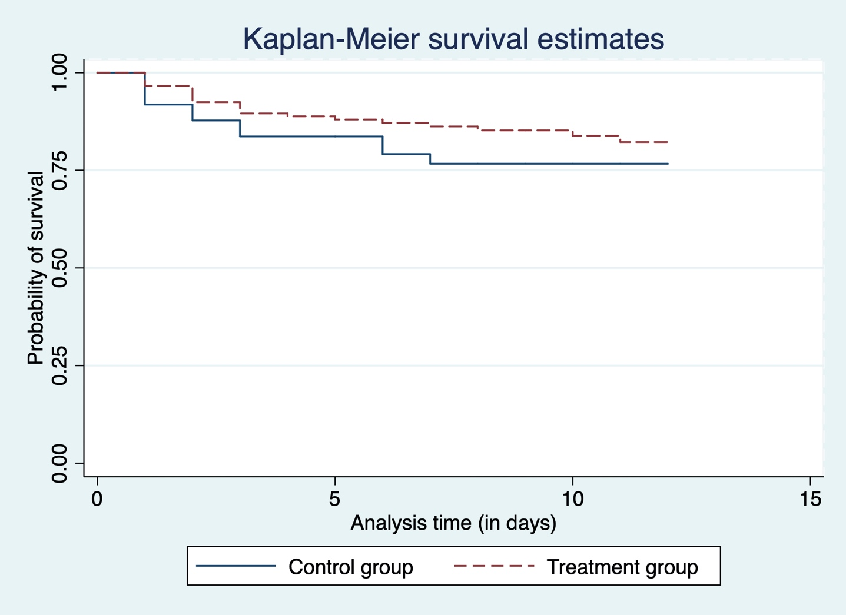
S1 Appendix: Probability of survival in treatment and control groups after exclusion of patients who died within 24 hours.

S2Appendix: Effect of treatment on mortality (after exclusion of patient died within 24 hours after admission).
Outcome | Time of follow-up | Unadjusted Hazard Ratio [95%CI] | p-value | Adjusted Hazard Ratio* [95%CI] | p-value
Mortality rate | At Day-12 | 0.66 [0.32-1.36] | 0.263 | 0.51 [0.23-1.12] | 0.095
 | At Day-6 | 0.60 [0.27-1.30] | 0.199 | 0.50 [0.21-1.16]- | 0.111
Recovery rate | At Day-12 | 0.85 [0.52-1.39] | 0.543 | 0.82 [0.48-1.40] | 0.473
 | At Day-6 | 1.29 [0.14-11.57] | 0.818 | 1.22 [0.10-15.06] | 0.871

*Adjusted for age, sex, hypertension, time from symptoms onset to admission and oxygen saturation at admission.

S3 Appendix: Effect of treatment on mortality with propensity score matching and exclusion of patients who died within 24 hours after admission.
Outcome | Time of follow-up | Unadjusted Hazard Ratio [95%CI] | p-value | Adjusted Hazard Ratio [95%CI] | p-value
Mortality rate | At Day-12 | 0.84 [0.34-2.02] | 0.699 | 0.42 [0.15-1.21] | 0.110
 | At Day-6 | 0.78 [0.30-1.98] | 0.604 | 0.50 [0.17-1.45] | 0.203
Recovery rate | At Day-12 | 0.82 [0.42-1.58] | 0.567 | 0.78 [0.36-1.70] | 0.546
 | At Day-6 | nd* | nd* | nd* | nd*
*not determined.

Analysis with Propensity score matching
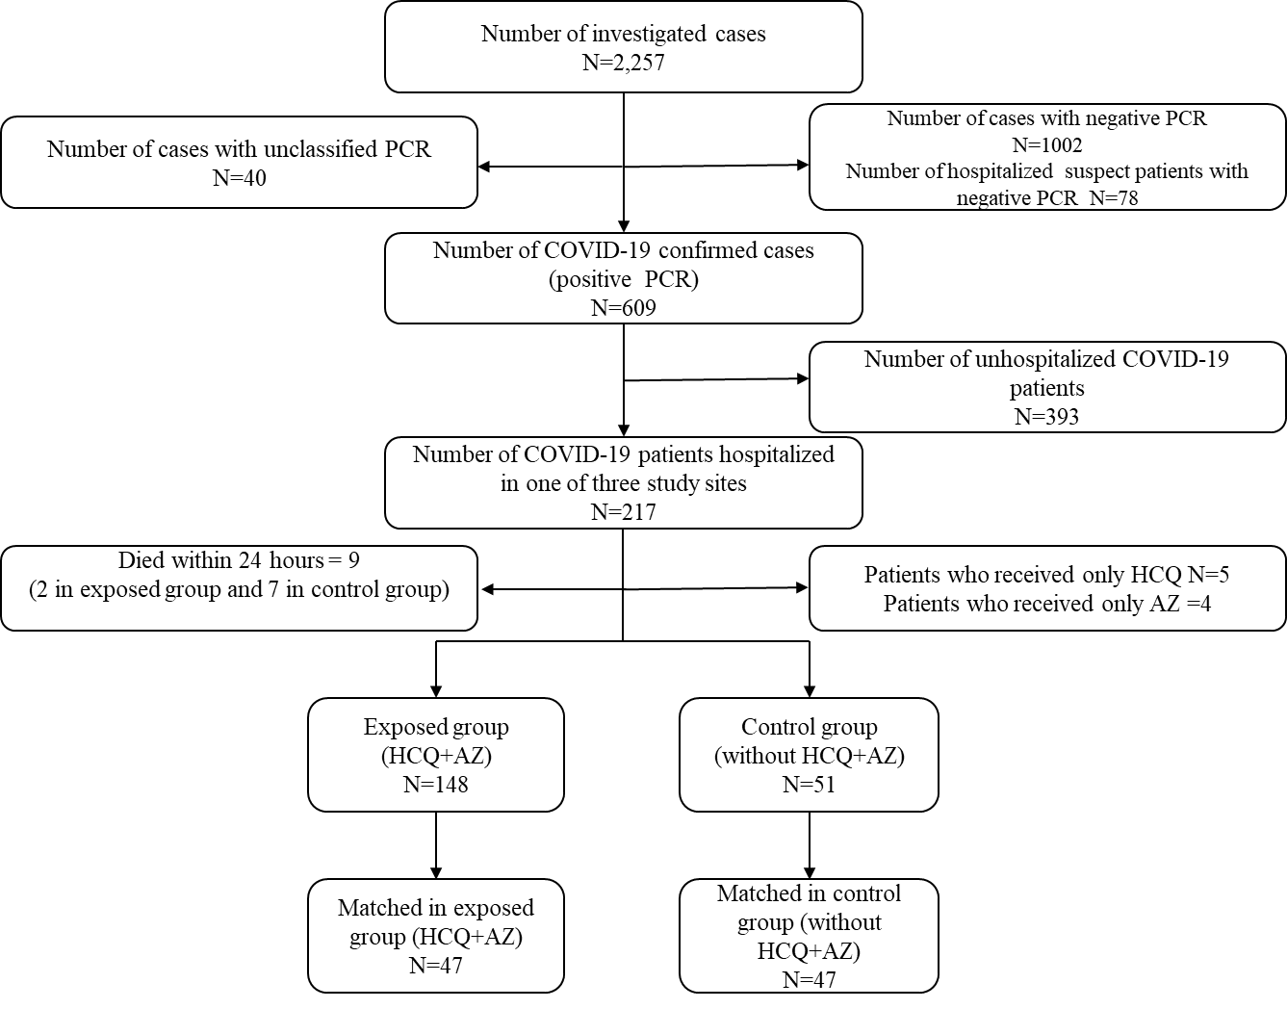
S4 Appendix: Flowchart of COVID19 patients for propensity score matching.

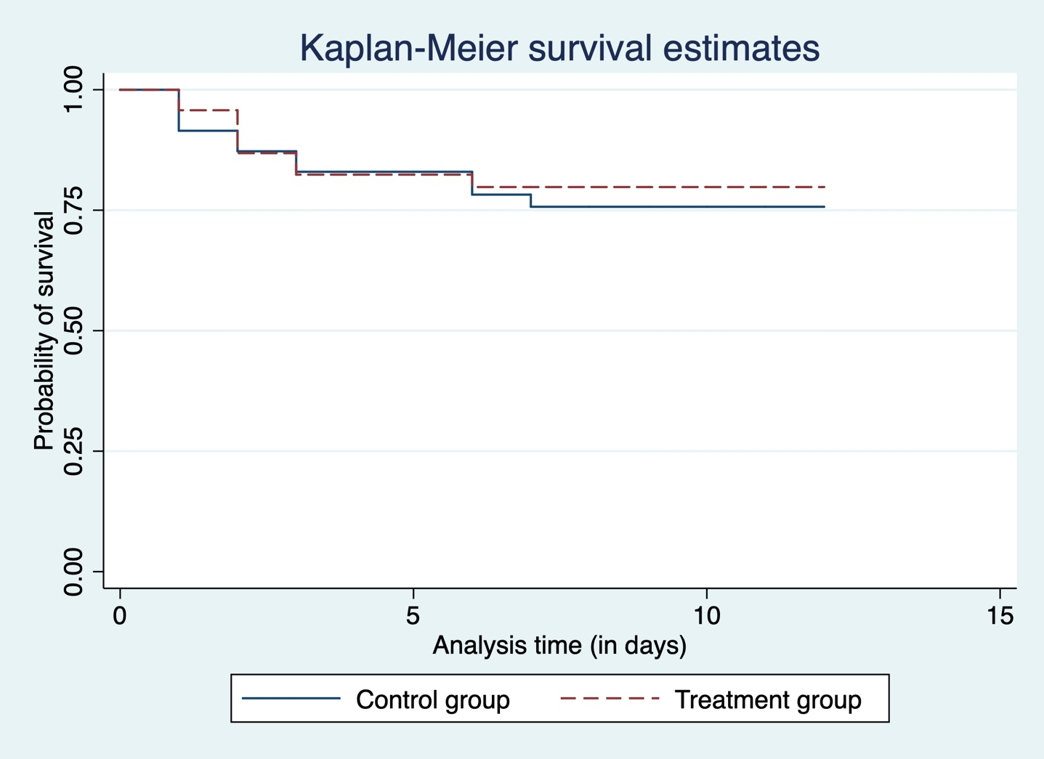
S5 Appendix: Survival probability in treatment and control groups in the propensity score matching.

