Supplementary

Methods: Search strategy
CENTRAL equation:
#1 randomized controlled trial [pt]
#2 controlled clinical trial [pt]
#3 randomized [tiab]
#4 placebo [tiab]
#5 clinical trials as topic [mesh: noexp]
#6 randomly [tiab]
#7 trial [ti]
#8 #1 OR #2 OR #3 OR #4 OR #5 OR #6 OR #7
#9 animals [mh] NOT humans [mh]
#10 #8 NOT #9
#11 "SARS-CoV-2"[Mesh]
#12 "COVID-19"[Mesh]
#13 Coronavirus*[Title]
#14 #11 OR #12 OR #13
#15 "Treatment"[Mesh]
#16 Treatment*[Title]
#17 #15 OR #16
#18 #10 AND #14 AND #17

MEDLINE equation:
(randomized controlled trial [pt] OR controlled clinical trial [pt] OR randomized [tiab] OR placebo [tiab] OR clinical trials as topic [mesh: noexp] OR randomly [tiab] OR trial [ti]) NOT (animals [mh] NOT humans [mh]) AND ("SARS-CoV-2"[Mesh] OR "COVID-19"[Mesh] OR COVID-19*[Title]) AND ("COVID-19"[Mesh] OR "SARS-CoV-2"[Mesh] SARS-CoV-2*[Title] OR COVID-19*[Title]).

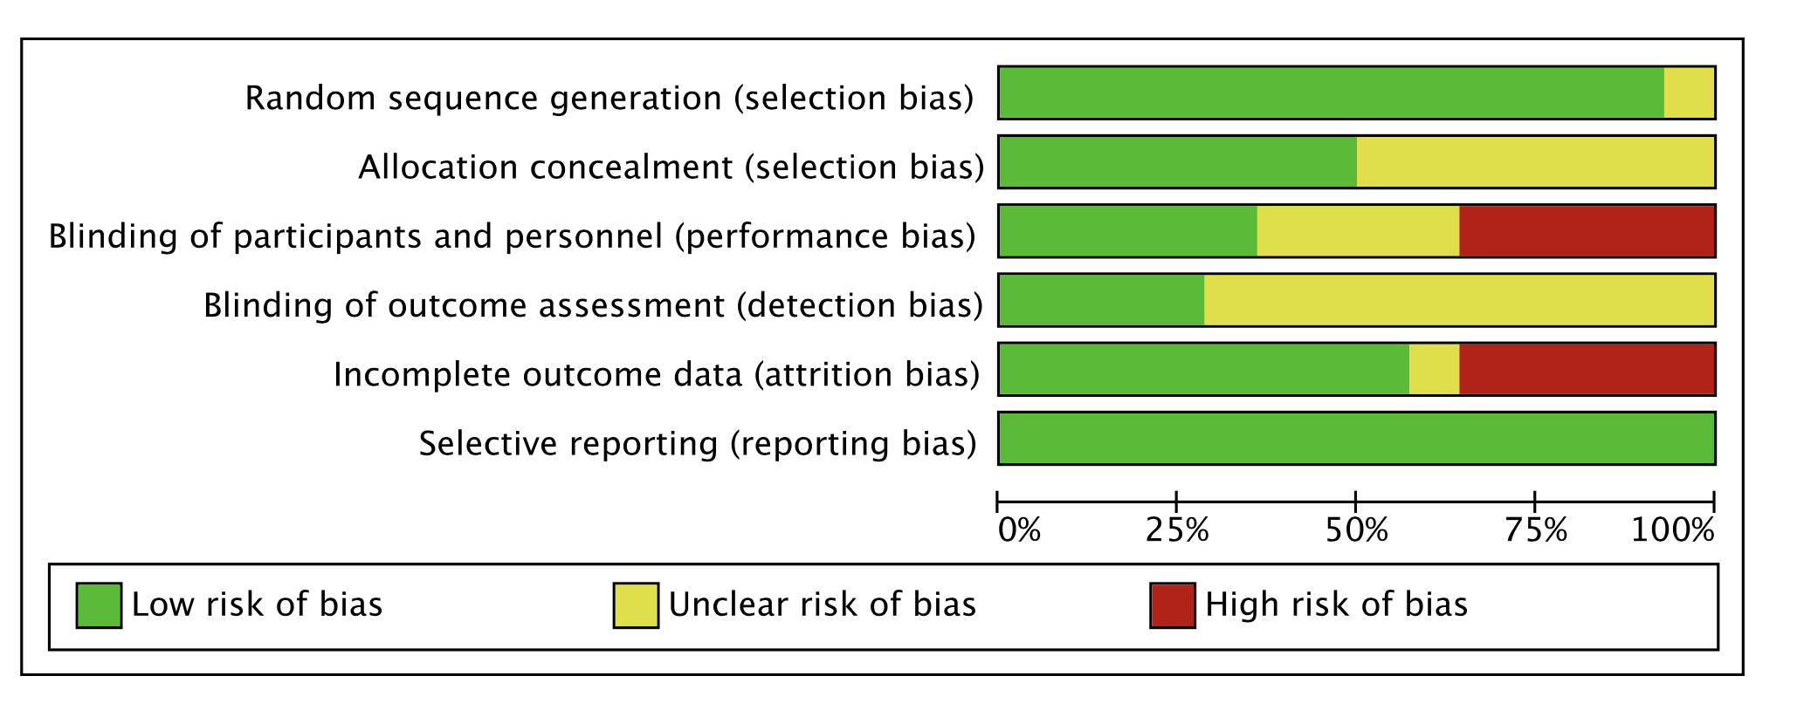
Figure 1: Summary of risk bias assessment for SARS-CoV-2 treatment comparisons.

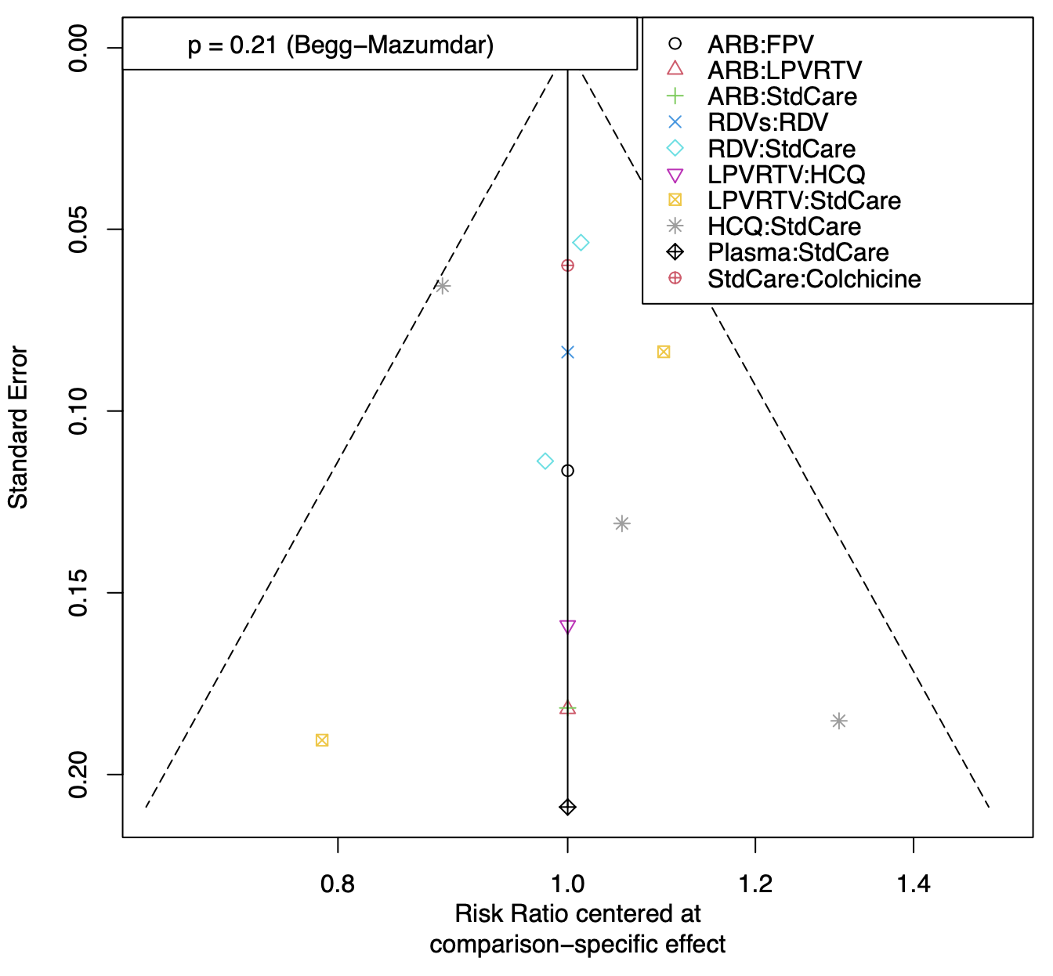
Figure 2: Comparison-adjusted funnel plot for SARS-CoV-2 comparisons for clinical improvement.

RDVs: Remdesivir for 5-day; RDV: Remdesivir more than 5-day; FPV: Favipiravir; LPVRTV: Lopinavir/ritonavir; ARB: Arbidol (umifenovir). Plasma: Convalescent plasma; StdCare: Standard of care; HCQ: Hydroxychloroquine.

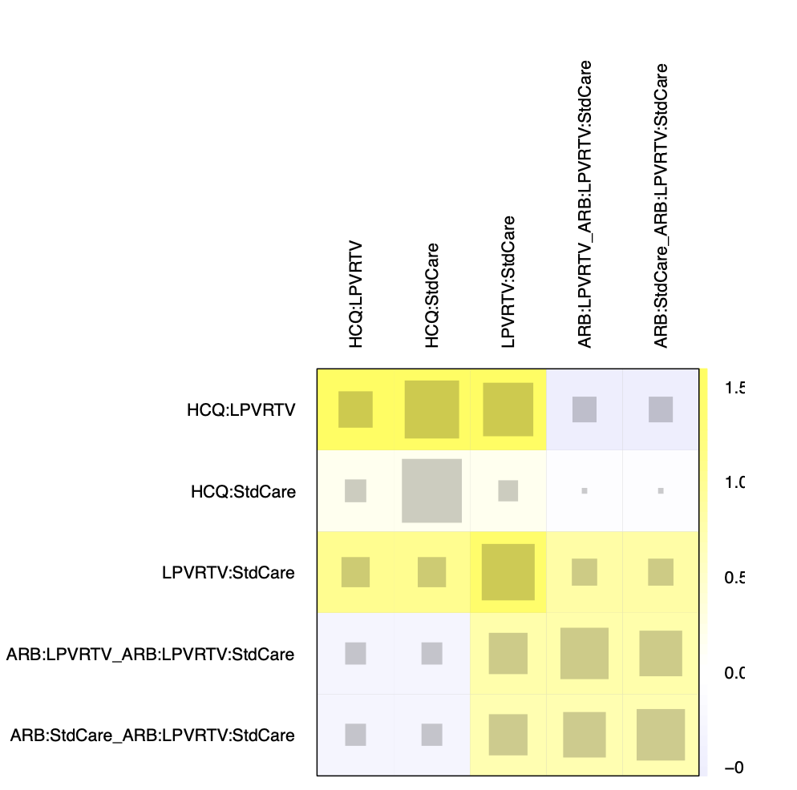

Figure 3: Heatmap to identify points of single design heterogeneity for clinical improvement in randomized studies.

RDVs: Remdesivir for 5-day; RDV: Remdesivir more than 5-day; FPV: Favipiravir; LPVRTV: Lopinavir/ritonavir; ARB: Arbidol (umifenovir). Plasma: Convalescent plasma; StdCare: Standard of care; HCQ: Hydroxychloroquine.
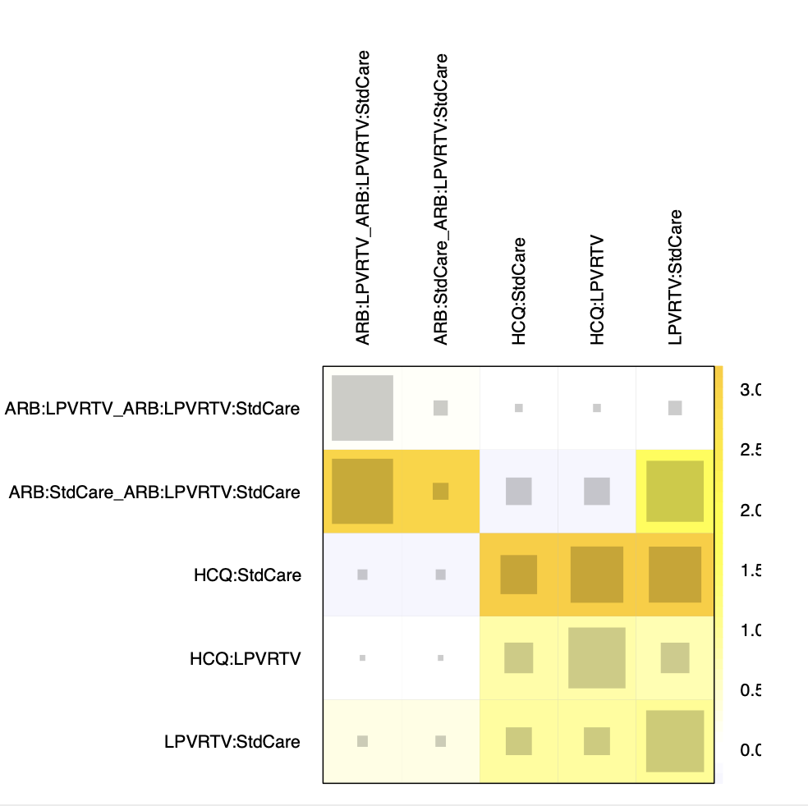

Figure 4: Heatmap to identify points of single design heterogeneity for any adverse event in randomized studies.
RDVs: Remdesivir for 5-day; RDV: Remdesivir more than 5-day; FPV: Favipiravir; LPVRTV: Lopinavir/ritonavir; ARB: Arbidol (umifenovir); Plasma: Convalescent plasma; StdCare: Standard of care; HCQ: Hydroxychloroquine.

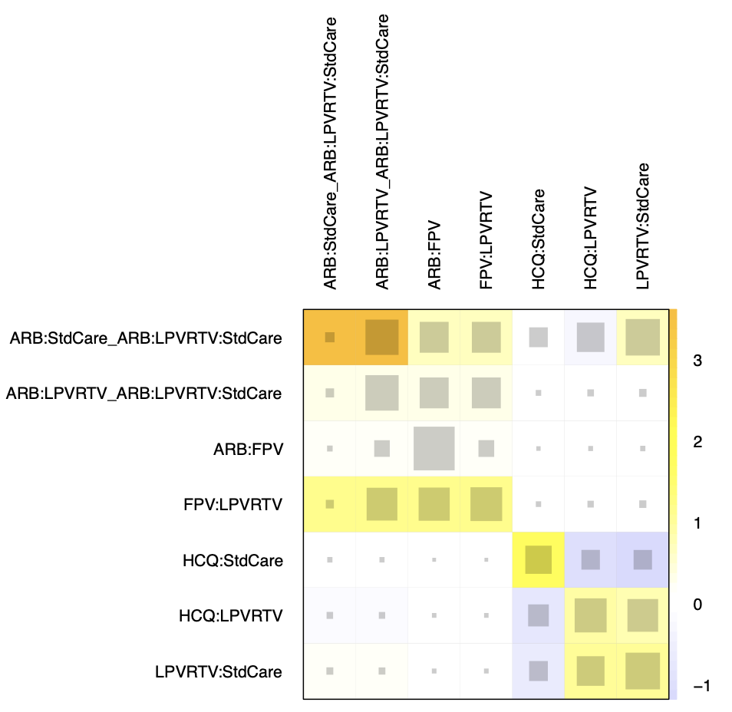
Figure 5: Heatmap to identify points of single design heterogeneity for any severe adverse event in randomized and observational studies.
RDVs: Remdesivir for 5-day; RDV: Remdesivir more than 5-day; FPV: Favipiravir; LPVRTV: Lopinavir/ritonavir; LPVRTVRBV: Lopinavir/ritonavir and ribavirin; ARB: Arbidol (umifenovir); Plasma: Convalescent plasma; StdCare: Standard of care; HCQlow: Low dose of hydroxychloroquine (450 mg); HCQ: Hydroxychloroquine.
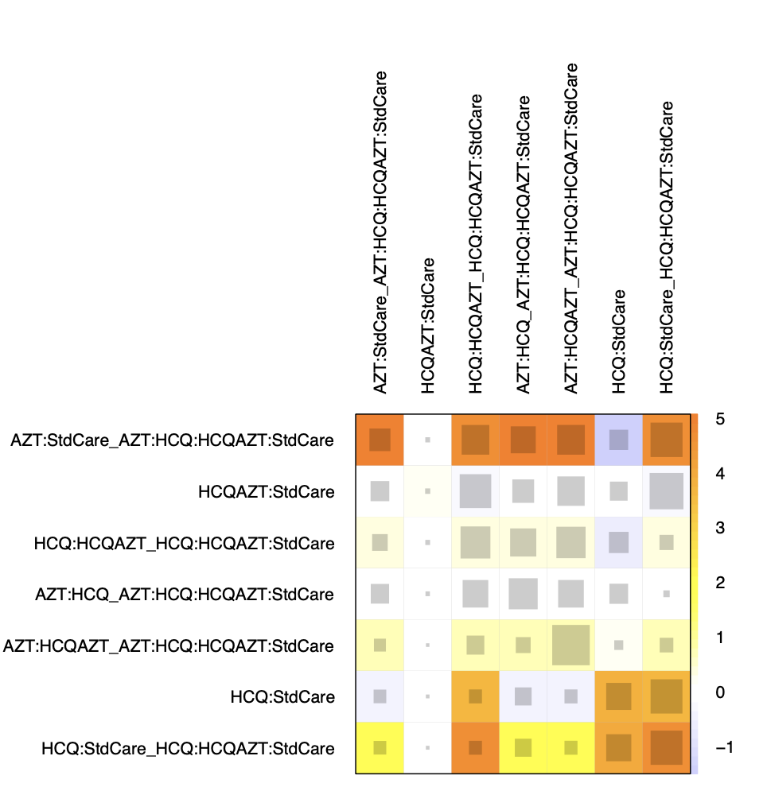

Figure 6: Heatmap to identify points of single design heterogeneity for all-cause mortality in randomized and observational studies.
RDVs: Remdesivir for 5-day; RDV: Remdesivir more than 5-day; FPV: Favipiravir; LPVRTV: Lopinavir/ritonavir; LPVRTVRBV: Lopinavir/ritonavir and ribavirin; ARB: Arbidol (umifenovir); Plasma: Convalescent plasma; StdCare: Standard of care; AZT: Azithromycin; HCQlow: Low dose of hydroxychloroquine (450 mg); HCQ: Hydroxychloroquine; HCQAZT: Association hydroxychloroquine and azithromycin.

Table 1: Characteristics of included observational nonrandomized comparative studies investigating the efficacy and safety of SARS-Cov-2 virus.
Study | Location | Study period (days) | Data sources | Dosing Information, number of participants randomized in each treatment group | Main primary endpoints; number of events in each arm) | Statistical analysis
Geleris, et al. [1] | US | March 7 to April 25 | NYP-CUIMC clinical data warehouse | 600 mg twice on day 1 then 400 mg daily for a median of 5 days of hydroxychloroquine (HCQ, n = 811);  Standard of care (SOC, n = 565) | Time from study baseline to intubation or death;  HCQ (n = 262); SOC (n = 84) | Propensity score-matched and Cox proportional-hazard regression analysis
Mahévas, et al. [2] | France | March 12 to April 24 | Health electronic records | 600 mg/day of HCQ within 48 h of admission to hospital (n = 84); SOC (n = 89) | Survival without transfer to the intensive care unit at day 21;  HCQ (n = 17); SOC (n = 22) | Propensity score-matched and Cox proportional-hazard regression analysis
Rosenberg, et al. [3] | US | March 15 to April 24 | NYS department of health electronic laboratory file and SHIN-NY data | HCQ alone (n = 271); HCQ + AZT (n = 735); AZT alone (n = 211); Neither drugs (n = 221) | In-hospital mortality;  HCQ (n = 54); AZT (n = 21);  HCQ + AZT (n = 189); SOC (n = 28) | Cox proportional-hazard regression analysis
Sbidian, et al. [4] | France | February 1st to April 6 | Corona OMOP database | 600 mg of HCQ alone on day 1, followed by 400 mg for 9 additional days (n = 623); 500 mg of azithromycin (AZT) on day 1 and then 250 mg daily for 4 more days plus HCQ (n = 227); Neither drug (n = 3,792) | All-cause 28-day mortality, assessed as time-to-event endpoint; HCQ alone (n = 111); HCQ plus azithromycin (AZT, n = 54); Neither drug (n = 830) | Propensity score-matched and cause-specific Cox proportional-hazard regression analysis
Barbosa, et al. [5] | Brazil | March 15 to March 31 | Michigan, SARS-CoV-2 cohort | 400 mg of HCQ for one to two days and three to four subsequent days of a 200 mg to 400 mg once daily dose (n = 32); SOC (n = 31) | Effect of HCQ on the need to escalate respiratory support, change in lymphocyte count, and change in neutrophil-to-lymphocyte ratio; HCQ (4 deaths); SOC (1 death) | Adjusted logistic regression
Yu Bo, et al [6] | China | February 1st to April 8 | Health care data from Tongji Hospital Wuhan | 200 mg of HCQ twice a day for 7-10 days (n = 48); non-HCQ treatment (n = 520) | In-hospital death and hospital stay time (day);  HCQ (n = 9); non-HCQ (n = 238) | Adjusted Cox proportional-hazard regression
Membrillo et al. [7] | Spain | NR | Health care date from Central Defense Hospital “Gómez Ulla” | 200 mg of HCQ twice a day for 7-10 days (n = 123); non-HCQ treatment (n = 43) | In-hospital death);  HCQ (n = 60); non-HCQ (n = 10) | KM analysis and adjusted logistic regression
Magagnoli, et al. [8] | US | March 9 to April 11 | VINCI database | HCQ (n = 97); HCQ + AZT (n = 113); No-HCQ (n = 158) | Death and need of mechanical ventilation;  HCQ (n = 27); HCQ + AZT (n = 25); No-HCQ (n = 18) | Propensity score-matched and Fine and Gray regression analysis
Huang, et al [9] | China | NR | NR | 500 mg of HCQ (n = 197); SOC (n = 176) | Time-to undetectable viral RNA. | KM analysis
Lagier, et al. [10] | France | March 3 to April 27 | IHU Mediterranean Infection database | 200 mg of HCQ, three times daily for ten days and 500 mg AZT on day 1 followed by 250 mg daily for the next four days (n = 3,337); HCQ alone (n = 101); AZT (n = 137); no-HCQ and no-AZT (n = 162) | Poor clinical outcome (transfer to ICU or death or hospitalization lasting ≥ 10 days); HCQ + AZT (n = 172); HCQ (n = 8); AZT (n = 37); No-HCQ and no-AZT (n = 13) | Propensity score-matched and Cox proportional-hazard regression analysis
Arshad, et al. [11] | US | March 10 to May 2 | Henry Ford Health System (HFHS) | 400 mg of HCQ, twice daily for 2 doses on day 1, followed by 200 mg twice daily on days 2-5 and 500 mg AZT on day 1 followed by 250 mg once daily for the next four days (n = 783); HCQ alone (n = 1202); AZT (n = 147); no-HCQ and no-AZT (n = 409) | In-hospital mortality; HCQ + AZT (n = 157); HCQ (n = 162); AZT (n = 33); No-HCQ and no-AZT (n = 108) | Propensity score-matched and Cox proportional-hazard regression analysis

VINCI: Veteran Affairs Informatics and Computing Infrastructure; AZT: Azithromycin; HCQ: Hydroxychloroquine; HCQAZT: Association hydroxychloroquine and azithromycin; SOC: Standard of care; KM: Kaplan-Meier; SARS-CoV-2: Severe acute respiratory syndrome coronavirus 2; NYS: New York State; NYP-CUIMC: Neu York-Presbyterian Hospital Columbia University Irving Medical Center; IHU: Institut hospital-universitaire; US: United State of America.

Table 2: League table of pairwise comparisons in network meta-analysis for clinical improvement.
RDVs | . | 1.19 (0.91-1.55) | . | . | . | . | . | .
1.15 (0.65-2.03) | Plasma | . | . | . | . | 1.20 (0.76-1.91) | . | .
1.19 (0.91-1.55) | 1.03 (0.63-1.69) | RDV | . | . | . | 1.17 (0.97-1.41) | . | .
1.20 (0.83-1.73) | 1.04 (0.64-1.70) | 1.01 (0.79-1.30) | HCQ | . | . | 1.13 (0.94-1.35) | 1.32 (0.90-1.92) | .
1.22 (0.81-1.83) | 1.05 (0.63-1.78) | 1.02 (0.75-1.39) | 1.01 (0.76-1.36) | Colchicine | . | 1.14 (0.90-1.46) | . | .
1.28 (0.71-2.29) | 1.11 (0.57-2.16) | 1.08 (0.64-1.81) | 1.07 (0.64-1.77) | 1.05 (0.61-1.81) | FPV | . | . | 1.15 (0.84-1.56)
1.39 (1.00-1.93) | 1.20 (0.76-1.91) | 1.17 (0.97-1.41) | 1.16 (0.98-1.37) | 1.14 (0.90-1.46) | 1.09 (0.67-1.76) | StdCare | 0.98 (0.78-1.22) | 1.16 (0.77-1.76)
1.41 (0.96-2.07) | 1.22 (0.74-2.02) | 1.19 (0.90-1.56) | 1.18 (0.93-1.48) | 1.16 (0.85-1.59) | 1.10 (0.68-1.79) | 1.02 (0.83-1.24) | LPVRTV | 0.94 (0.62-1.42)
1.46 (0.89-2.40) | 1.27 (0.70-2.29) | 1.23 (0.81-1.87) | 1.22 (0.82-1.81) | 1.20 (0.77-1.87) | 1.15 (0.84-1.56) | 1.05 (0.73-1.52) | 1.04 (0.72-1.50) | ARB

Treatment are ordered in the rank of their chance of being the best option. Treatment estimates are provided as risk ratios (RR) with 95% CIs. Indirect comparisons between treatment should be red left to right, and their RR is in the cell in common between the column-defining treatment and the row-defining treatment. RRs > 1 favor the column-defining treatment for the network estimates; Bold value correspond to statistically significant value; Upper triangle were direct comparison, and lower triangle were indirect comparison; RDVs: Remdesivir for 5-day; RDV: Remdesivir more than 5-day; FPV: Favipiravir; LPVRTV: Lopinavir/ritonavir; ARB: Arbidol (umifenovir). Plasma: Convalescent plasma; StdCare: Standard of care; HCQlow: Low dose of hydroxychloroquine (450 mg); HCQ: Hydroxychloroquine.

Table 3: League table of pairwise comparisons in network meta-analysis for all-cause mortality in randomized studies.
Colchicine | . | . | . | . | 0.23 (0.02-2.19)
0.41 (0.03-5.08) | RDVs | . | 0.75 (0.30-1.90) | . | .
0.35 (0.03-4.25) | 0.86 (0.18-4.02) | Plasma | . | . | 0.65 (0.23-1.90)
0.30 (0.03-3.20) | 0.75 (0.30-1.90) | 0.88 (0.25-3.01) | RDV | . | 0.75 (0.40-1.40)
0.30 (0.03-3.36) | 0.73 (0.18-3.02) | 0.85 (0.22-3.37) | 0.97 (0.33-2.85) | LPVRTV | 0.77 (0.32-1.84)
0.23 (0.02-2.19) | 0.56 (0.18-1.72) | 0.65 (0.23-1.90) | 0.75 (0.40-1.40) | 0.77 (0.32-1.84) | StdCare

Treatment are ordered in the rank of their chance of being the best option. Treatment estimates are provided as risk ratios (RR) with 95% CIs. Indirect comparisons between treatment should be red left to right, and their RR is in the cell in common between the column-defining treatment and the row-defining treatment. RRs > 1 favor the column-defining treatment for the network estimates; Bold value correspond to statistically significant value; Upper triangle were direct comparison, and lower triangle were indirect comparison; RDVs: Remdesivir for 5-day; RDV: Remdesivir more than 5-day; LPVRTV: Lopinavir/ritonavir.

Table 4: League table of pairwise comparisons in network meta-analysis for any adverse event.
ARB | . | 0.76 (0.42-1.36) | . | . | 5.42 (0.31-95.35) | . | 0.43 (0.16-1.13) | . | . | .
0.70 (0.21- 2.39) | HCQLow | . | . | . | . | . | . | 0.50 (0.27-0.90) | . | .
0.76 (0.42-1.36) | 1.07 (0.28-4.17) | FPV | . | . | . | . | . | . | . | .
0.64 (0.19-2.07) | 0.90 (0.35- 2.33) | 0.84 (0.22-3.14) | RDVs | 0.96 (0.63-1.47) | . | . | . | . | . | .
0.61 (0.20-1.83) | 0.86 (0.37-2.02) | 0.80 (0.23-2.80) | 0.96 (0.63-1.47) | RDV | 0.94 (0.69-1.30) | . | . | . | . | .
0.57 (0.20-1.65) | 0.82 (0.37-1.79) | 0.76 (0.23-2.54) | 0.91 (0.53-1.54) | 0.94 (0.69-1.30) | StdCare | . | 0.97 (0.59-1.59) | 0.41 (0.20-0.84) | 0.20 (0.01-4.26) | 0.38 (0.21-0.70)
0.48 (0.16-1.46) | 0.68 (0.27-1.72) | 0.63 (0.18-2.22) | 0.75 (0.31-1.81) | 0.78 (0.36-1.70) | 0.83 (0.41-1.68) | LPVRTVRBV | 0.98 (0.56-1.71) | . | . | .
0.46 (0.18-1.23) | 0.66 (0.31-1.39) | 0.61 (0.20-1.91) | 0.73 (0.37-1.45) | 0.76 (0.45-1.31) | 0.81 (0.52-1.24) | 0.98 (0.56- 1.71) | LPVRTV | 0.93 (0.55-1.56) | . | .
0.35 (0.12-1.02) | 0.50 (0.27-0.90) | 0.46 (0.14-1.56) | 0.55 (0.26-1.15) | 0.57 (0.31-1.05) | 0.61 (0.36-1.01) | 0.73 (0.36- 1.51) | 0.75 (0.48-1.18) | HCQ | . | .
0.12 (0.00-2.93) | 0.17 (0.01-3.84) | 0.15 (0.01-4.08) | 0.18 (0.01-4.04) | 0.19 (0.01-4.09) | 0.20 (0.01-4.26) | 0.25 (0.01- 5.59) | 0.25 (0.01-5.43) | 0.34 (0.02-7.32) | Plasma | .
0.22 (0.07-0.74) | 0.31 (0.12-0.84) | 0.29 (0.08-1.12) | 0.35 (0.16-0.78) | 0.36 (0.18-0.72) | 0.38 (0.21-0.70) | 0.46 (0.18- 1.18) | 0.47 (0.23-1.00) | 0.63 (0.29-1.39) | 1.88 (0.08-41.72) | Colchicine

Treatment are ordered in the rank of their chance of being the best option. Treatment estimates are provided as risk ratios (RR) with 95% CIs. Indirect comparisons between treatment should be red left to right, and their RR is in the cell in common between the column-defining treatment and the row-defining treatment. RRs > 1 favor the column-defining treatment for the network estimates; Bold value correspond to statistically significant value; Upper triangle were direct comparison, and lower triangle were indirect comparison; RDVs: remdesivir for 5-day; RDV: Remdesivir more than 5-day; FPV: Favipiravir; LPVRTV: Lopinavir/ritonavir; LPVRTVRBV: Lopinavir/ritonavir and ribavirin; ARB: Arbidol (umifenovir). Plasma: Convalescent plasma; StdCare: Standard of care; AZT: Azithromycin; HCQlow: Low dose of hydroxychloroquine (450 mg); HCQ: Hydroxychloroquine; HCQAZT: Association hydroxychloroquine and azithromycin.

Table 5: League table of pairwise comparisons in network meta-analysis for any severe adverse event.
LPVRTVRBV | . | 0.16 (0.01-3.84) | . | . | .
0.20 (0.01-5.23) | RDVs | . | 0.61 (0.44-0.85) | . | .
0.16 (0.01-3.84) | 0.78 (0.42-1.46) | LPVRTV | . | 0.60 (0.37-0.98) | .
0.12 (0.00-3.13) | 0.61 (0.44-0.85) | 0.78 (0.46-1.33) | RDV | 0.77 (0.63-0.94) | .
0.10 (0.00-2.39) | 0.47 (0.32-0.69) | 0.60 (0.37-0.98) | 0.77 (0.63-0.94) | StdCare | 0.20 (0.01-4.10)
0.02 (0.00-1.58) | 0.09 (0.00-1.97) | 0.12 (0.01-2.56) | 0.15 (0.01-3.17) | 0.20 (0.01-4.10) | HCQ

Treatment are ordered in the rank of their chance of being the best option. Treatment estimates are provided as risk ratios (RR) with 95% CIs. Indirect comparisons between treatment should be red left to right, and their RR is in the cell in common between the column-defining treatment and the row-defining treatment. RRs > 1 favor the column-defining treatment for the network estimates; Bold value correspond to statistically significant value; Upper triangle were direct comparison, and lower triangle were indirect comparison; RDVs: Remdesivir for 5-day; RDV: Remdesivir more than 5-day; LPVRTV: Lopinavir/ritonavir; LPVRTVRBV: Lopinavir/ritonavir and ribavirin; ARB: Arbidol (umifenovir). Plasma: Convalescent plasma; StdCare: Standard of care; HCQ: Hydroxychloroquine.

Table 6: League table of pairwise comparisons in network meta-analysis for all-cause mortality in randomized and observational studies.
Colchicine | . | . | . | . | . | 0.23 (0.02-2.40) | . | . | .
0.54 (0.04-7.94) | HCQLow | . | . | . | . | . | . | . | 0.38 (0.11-1.35)
0.40 (0.03-6.06) | 0.74 (0.11-4.93) | RDVs | . | 0.75 (0.24-2.32) | . | . | . | . | .
0.35 (0.02-4.99) | 0.65 (0.11-3.94) | 0.88 (0.14-5.57) | Plasma | . | . | 0.65 (0.19-2.27) | . | . | .
0.30 (0.02-3.56) | 0.56 (0.12-2.55) | 0.75 (0.24-2.32) | 0.86 (0.20-3.71) | RDV | . | 0.76 (0.35-1.66) | . | . | .
0.30 (0.02-3.96) | 0.55 (0.10-3.02) | 0.75 (0.13-4.28) | 0.85 (0.16-4.43) | 0.99 (0.26-3.76) | LPVRTV | 0.77 (0.26-2.27) | . | . | .
0.23 (0.02-2.40) | 0.42 (0.11-1.57) | 0.57 (0.15-2.26) | 0.65 (0.19-2.27) | 0.76 (0.35-1.66) | 0.77 (0.26-2.27) | StdCare | 1.10 (0.56-2.15) | 0.91 (0.57-1.46) | 0.90 (0.63-1.29)
0.20 (0.02-2.32) | 0.38 (0.09-1.54) | 0.52 (0.12-2.30) | 0.59 (0.15-2.34) | 0.69 (0.26-1.83) | 0.69 (0.20-2.38) | 0.90 (0.50-1.63) | AZT | 1.05 (0.56-1.99) | 1.03 (0.52-2.02)
0.21 (0.02-2.28) | 0.39 (0.10-1.47) | 0.52 (0.12-2.21) | 0.60 (0.16-2.23) | 0.70 (0.28-1.70) | 0.70 (0.22-2.26) | 0.91 (0.58-1.42) | 1.01 (0.56-1.84) | HCQAZT | 1.11 (0.69-1.78)
0.21 (0.02-2.23) | 0.38 (0.11-1.35) | 0.52 (0.13-2.14) | 0.59 (0.16-2.16) | 0.69 (0.29-1.63) | 0.70 (0.22-2.18) | 0.91 (0.63-1.30) | 1.01 (0.55-1.83) | 0.99 (0.64-1.55) | HCQ

Treatment are ordered in the rank of their chance of being the best option. Treatment estimates are provided as risk ratios (RR) with 95% CIs. Indirect comparisons between treatment should be red left to right, and their RR is in the cell in common between the column-defining treatment and the row-defining treatment. RRs > 1 favor the column-defining treatment for the network estimates; Bold value correspond to statistically significant value; Upper triangle were direct comparison, and lower triangle were indirect comparison; RDVs: remdesivir for 5-day; RDV: Remdesivir more than 5-day; FPV: Favipiravir; LPVRTV: Lopinavir/ritonavir; LPVRTVRBV: Lopinavir/ritonavir and ribavirin; ARB: Arbidol (umifenovir). Plasma: Convalescent plasma; StdCare: Standard of care; AZT: Azithromycin; HCQlow: Low dose of hydroxychloroquine (450 mg); HCQ: Hydroxychloroquine; HCQAZT: Association hydroxychloroquine and azithromycin.

Table 7: League table of pairwise comparisons in network meta-analysis for any adverse event in randomized and observational studies.
ARB | . | . | . | . | 5.42 (0.29-101.71) | 0.76 (0.32- 1.76) | . | 0.43 (0.14- 1.35) | . | . | . | .
0.79 (0.20-3.18) | AZT | . | . | . | 1.08 (0.53- 2.19) | . | . | . | 0.50 (0.26-0.97) | 0.42 (0.22-0.82) | . | .
0.74 (0.16- 3.56) | 0.94 (0.31- 2.87) | RDVs | 0.96 (0.45- 2.02) | . | . | . | . | . | . | . | . | .
0.71 (0.18- 2.82) | 0.90 (0.39- 2.07) | 0.96 (0.45- 2.02) | RDV | . | 0.95 (0.55- 1.62) | . | . | . | . | . | . | .
0.73 (0.16- 3.36) | 0.92 (0.32- 2.63) | 0.98 (0.26- 3.64) | 1.02 (0.34- 3.02) | HCQLow | . | . | . | . | . | 0.50 (0.21- 1.17) | . | .
0.67 (0.19- 2.39) | 0.85 (0.45- 1.61) | 0.91 (0.36- 2.27) | 0.95 (0.55- 1.62) | 0.93 (0.36- 2.39) | StdCare | . | . | 0.88 (0.41- 1.88) | 0.46 (0.24- 0.89) | 0.52 (0.34- 0.80) | 0.20 (0.01- 4.53) | 0.38 (0.16- 0.91)
0.76 (0.32- 1.76) | 0.95 (0.19- 4.86) | 1.02 (0.17- 6.03) | 1.06 (0.21- 5.34) | 1.04 (0.18- 6.01) | 1.12 (0.24- 5.15) | FPV | . | . | . | . | . | .
0.50 (0.12- 2.03) | 0.63 (0.20- 2.00) | 0.67 (0.17- 2.62) | 0.70 (0.22- 2.20) | 0.68 (0.18- 2.59) | 0.74 (0.27- 2.03) | 0.66 (0.13- 3.40) | LPVRTVRBV | 0.98 (0.43- 2.24) | . | . | . | .
0.48 (0.15- 1.52) | 0.61 (0.27- 1.38) | 0.65 (0.22- 1.94) | 0.68 (0.31- 1.51) | 0.67 (0.24- 1.89) | 0.72 (0.40- 1.29) | 0.64 (0.15- 2.65) | 0.98 (0.43- 2.24) | LPVRTV | . | 0.93 (0.41- 2.07) | . | .
0.44 (0.11- 1.69) | 0.55 (0.29- 1.04) | 0.59 (0.20- 1.72) | 0.61 (0.28- 1.33) | 0.60 (0.22- 1.64) | 0.65 (0.37- 1.14) | 0.58 (0.12- 2.85) | 0.88 (0.29- 2.69) | 0.90 (0.43- 1.91) | HCQAZT | 0.70 (0.40- 1.23) | . | .
0.36 (0.10- 1.29) | 0.45 (0.24-0.84) | 0.48 (0.18- 1.32) | 0.51 (0.26-0.99) | 0.50 (0.21- 1.17) | 0.53 (0.36-0.80) | 0.48 (0.10- 2.19) | 0.73 (0.26- 2.01) | 0.74 (0.41- 1.34) | 0.82 (0.49- 1.39) | HCQ | . | .
0.14 (0.00- 3.91) | 0.17 (0.01- 4.11) | 0.18 (0.01- 4.69) | 0.19 (0.01- 4.48) | 0.19 (0.01- 4.84) | 0.20 (0.01- 4.53) | 0.18 (0.01- 5.74) | 0.28 (0.01- 7.23) | 0.28 (0.01- 6.65) | 0.31 (0.01- 7.34) | 0.38 (0.02- 8.70) | Plasma | .
0.26 (0.06- 1.20) | 0.33 (0.11-0.95) | 0.35 (0.10- 1.22) | 0.36 (0.13-1.00) | 0.36 (0.10- 1.28) | 0.38 (0.16-0.91) | 0.34 (0.06- 1.97) | 0.52 (0.14- 1.97) | 0.53 (0.19- 1.51) | 0.59 (0.21- 1.65) | 0.72 (0.28- 1.86) | 1.88 (0.08-46.98) | Colchicine
Treatment are ordered in the rank of their chance of being the best option. Treatment estimates are provided as risk ratios (RR) with 95% CIs. Indirect comparisons between treatment should be red left to right, and their RR is in the cell in common between the column-defining treatment and the row-defining treatment. RRs > 1 favor the column-defining treatment for the network estimates; Bold value correspond to statistically significant value; Upper triangle were direct comparison, and lower triangle were indirect comparison; RDVs: Remdesivir for 5-day; RDV: Remdesivir more than 5-day; FPV: Favipiravir; LPVRTV: Lopinavir/ritonavir; LPVRTVRBV: Lopinavir/ritonavir and ribavirin; ARB: Arbidol (umifenovir). Plasma: Convalescent plasma; StdCare: Standard of care; AZT: Azithromycin; HCQlow: Low dose of hydroxychloroquine (450 mg); HCQ: Hydroxychloroquine; HCQAZT: Association hydroxychloroquine and azithromycin.

Reference
- Geleris J, Sun Y, Platt J, Zucker J, Baldwin M, et al. (2020) Observational study of hydroxychloroquine in hospitalized patients with Covid-19. N Engl J Med 382: 2411-2418.
- Mahévas M, Tran V-T, Roumier M, Chabrol A, Paule R, et al. (2020) Clinical efficacy of hydroxychloroquine in patients with covid-19 pneumonia who require oxygen: observational comparative study using routine care data. BMJ 369: m1844.
- Rosenberg ES, Dufort EM, Udo T, Wilberschied LA, Kumar J, et al. (2020) Association of treatment with hydroxychloroquine or azithromycin with in-hospital mortality in patients with COVID-19 in New York State. JAMA 323: 2493-2502.
- Sbidian E, Josse J, Lemaitre G, Mayer I, Bernaux M, et al. (2020) Hydroxychloroquine with or without azithromycin and in-hospital mortality or discharge in patients hospitalized for COVID-19 infection: A cohort study of 4,642 in-patients in France. Pharmacology and Therapeutics.
- Barbosa J, Kaitis D, Freedman R, Le K, Lin X (2020) Clinical outcomes of hydroxychloroquine in hospitalized patients with COVID-19: A quasi-randomized comparative study.
- Yu B, Wang DW, Li C (2020) Hydroxychloroquine application is associated with a decreased mortality in critically ill patients with COVID-19. Emergency Medicine.
- Membrillo FJ, Ramírez-Olivencia G, Estébanez M, de Dios B, Herrero M, et al. (2020) Early hydroxychloroquine is associated with an increase of survival in COVID-19 patients: An observational study.
- Magagnoli J, Narendran S, Pereira F, Cummings T, Hardin JW, et al. (2020) Outcomes of hydroxychloroquine usage in United States veterans hospitalized with Covid-19. Infectious Diseases.
- Huang M, Li M, Xiao F, Liang J, Pang P, et al. (2020) Preliminary evidence from a multicenter prospective observational study of the safety and efficacy of chloroquine for the treatment of COVID-19. Infectious Diseases.
- Lagier J-C, Million M, Gautret P, Colson P, Cortaredona S, et al. (2020) Outcomes of 3,737 COVID-19 patients treated with hydroxychloroquine/azithromycin and other regimens in Marseille, France: A retrospective analysis. Travel Med Infect Dis, 101791.
- Arshad S, Kilgore P, Chaudhry ZS, Jacobsen G, Wang DD, et al. (2020) Treatment with hydroxychloroquine, azithromycin, and combination in patients hospitalized with COVID-19. Int J Infect Dis 97: 396-403.

