Cell Prolifertion, Contact Inhibition and Apoptosis Prfilifing in a Benign and Malignant Breast Lesion
Supplementary Material
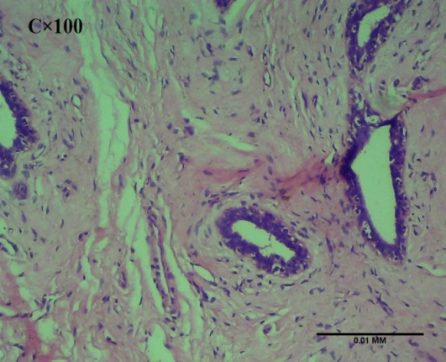 | 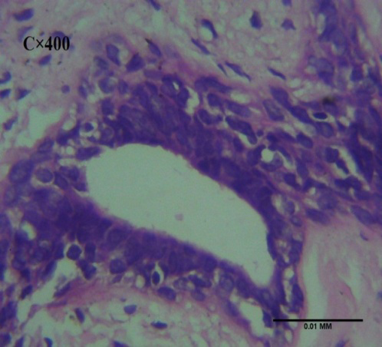
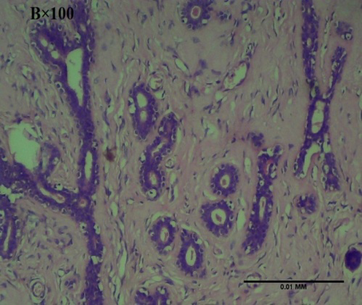 | 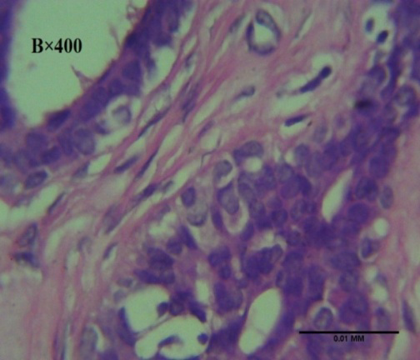
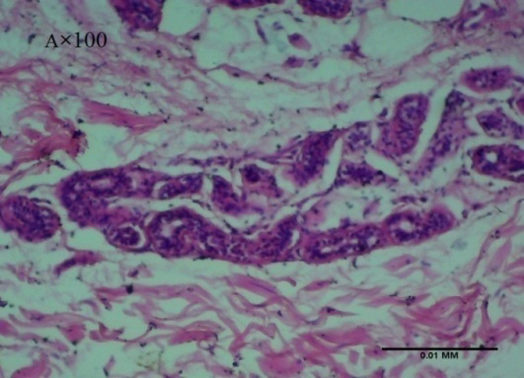 | 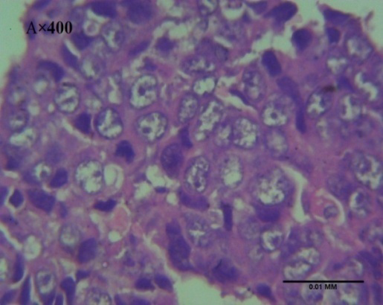

Figure S1: Haematoxylin and Eosin Plates.
Stained sections of normal at x100 and x400 (plate C) showing normal breast tissue morphology.; fibroadenoma at x100 and x400 (plate B) showing slight ductal occlusion and thickened stromal lines; invasive ductal adenocarcinoma at x100 and x400 (plate A) showing ductal occlusion, hyperchromasia, dysplasia.

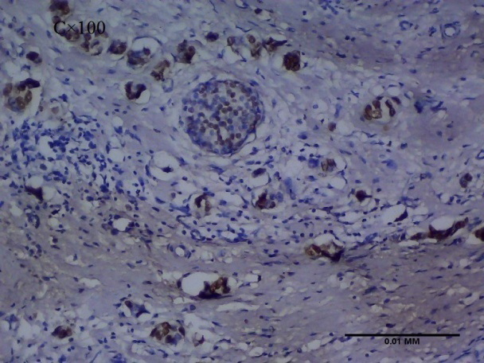 | 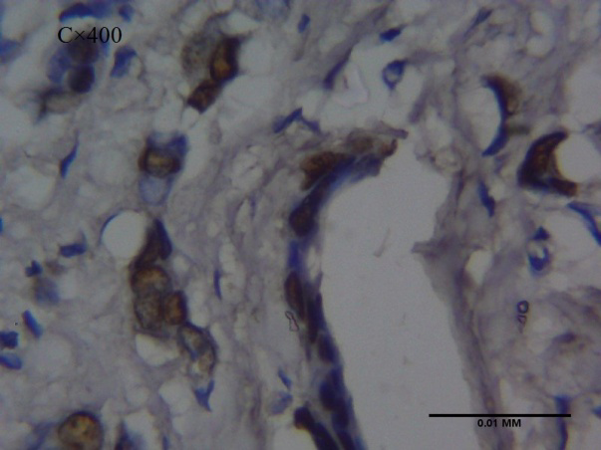
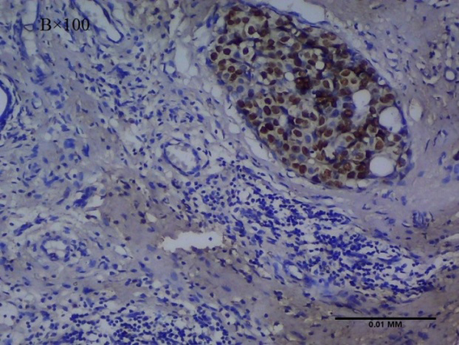 | 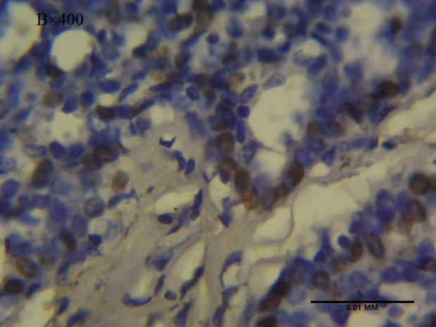
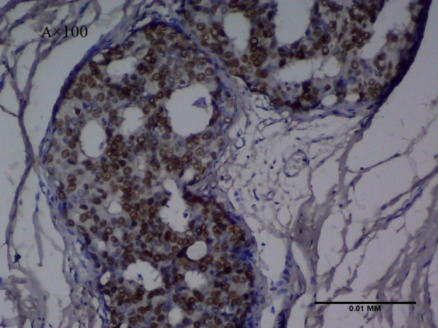 | 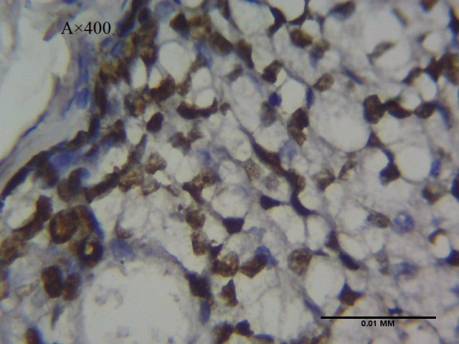

Figure S2: KI67 Immunohistochemistry Plates.
Nuclear KI67 stained sections of normal at x100 and x400 (plate C); fibroadenoma at x100 and x400 (plate B); invasive ductal adenocarcinoma at x100 and x400 (plate A). Insignificant KI67 immunohistochemical stains in normal prostatic tissue (plate C), moderate immunohistochemical staining within the cytoplasm of fibroadenoma (plate B) and moderate to severe immunohistochemical staining in invasive ductal adenocarcinoma (plate A).

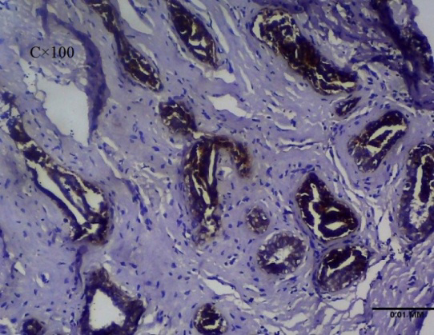 | 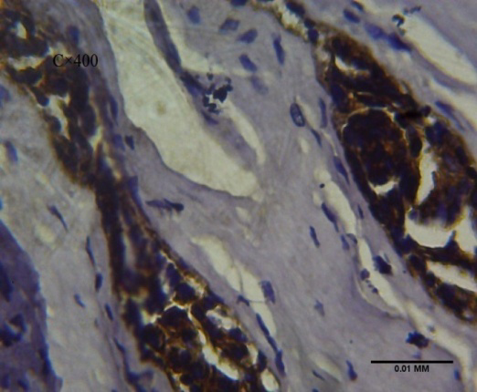
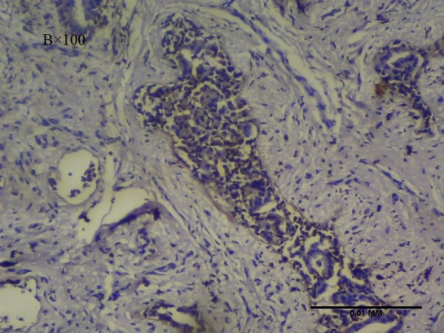 | 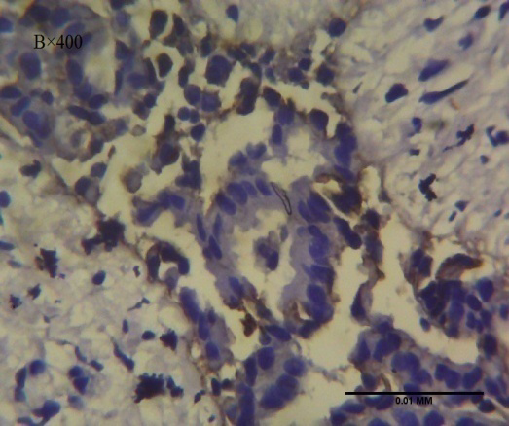
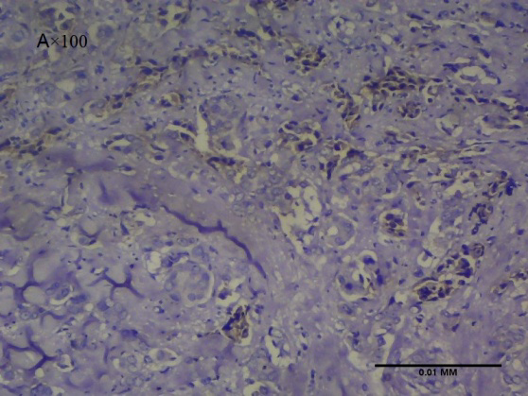 | 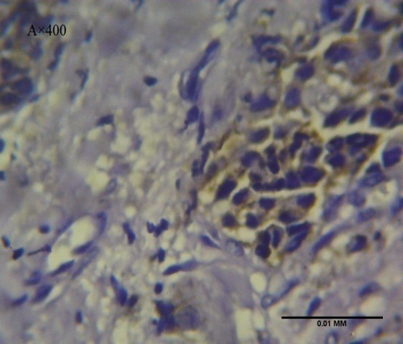

Figure S3: E-cadherin Immunohistochemistry Plates
Membranous ECAD immunohistochemical staining on sections of Normal at x100 and x400 (plate C); Fibroadenoma at x100 and x400 (plate B); Invasive ductal adenocarcinoma at x100 and x400 (plate A). Strong membranous immunohistochemical staining observed in the epithelial cells in normal (plate C), significant immunohistochemical staining observed in fibroadenoma (plate B) and weak immunohistochemical staining observed in invasive ductal adenocarcinoma (plate A)
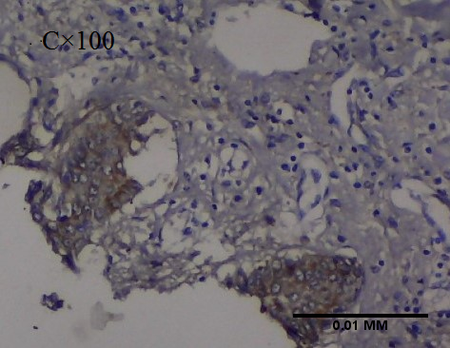 | 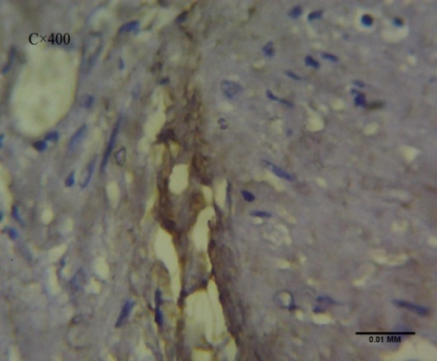
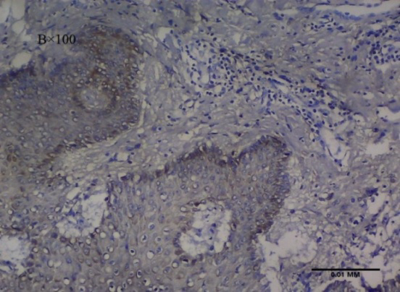 | 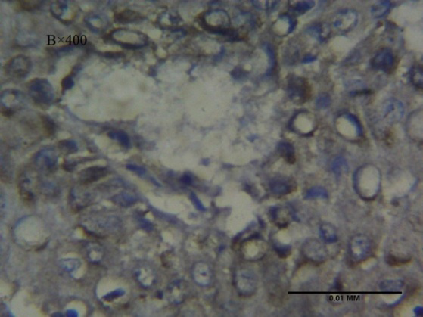
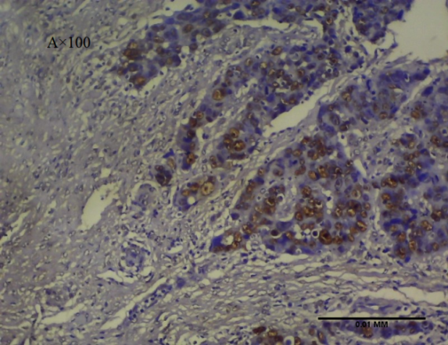 | 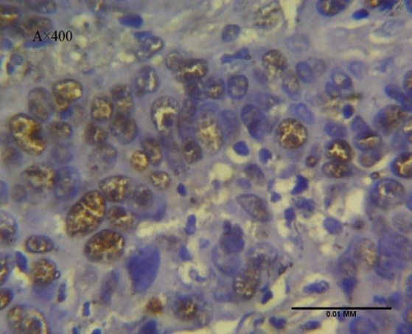

Figure S4: P53 Immunohistochemistry Plates.
Nuclear P53 stained sections of normal at x100 and x400 (plate C); fibroadenoma at x100 and x400 (plate B); invasive ductal adenocarcinoma at x100 and x400 (plate A). Insignificant p53 immunohistochemical staining in normal breast tissue (plate C), moderate immunohistochemical staining within the nucleus of fibroadenoma (plate B) and moderate to severe immunohistochemical staining in invasive ductal adenocarcinoma (plate A).

