Annexes
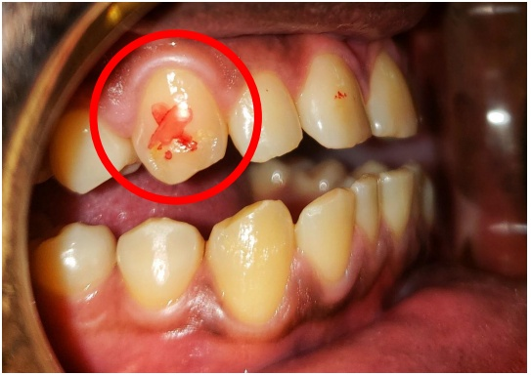
Marking of the percussion zone of a canine
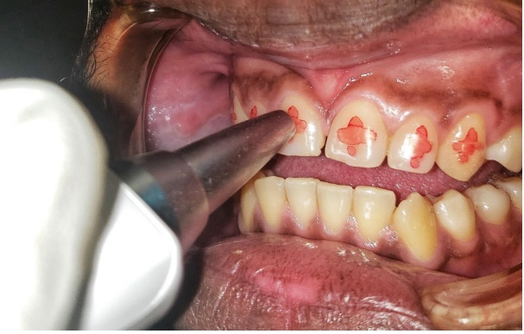
Measuring the stability value of a central incisor
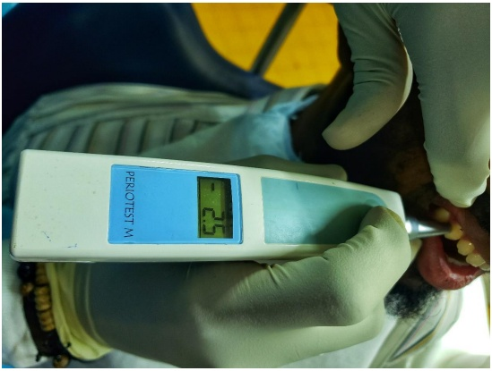
Periotest value displayed on the screen
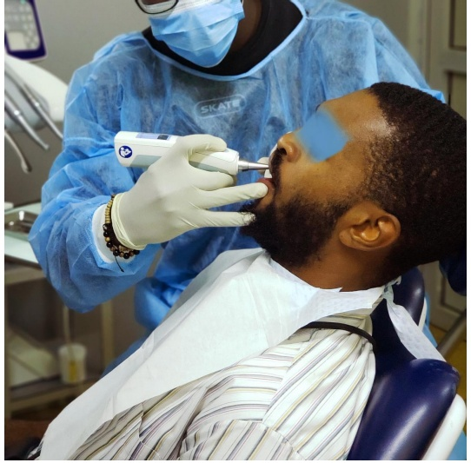
Patient in half-seated position and Periotest M in horizontal position

