Appendices
Appendix 1: Gender distribution (by number and percent).

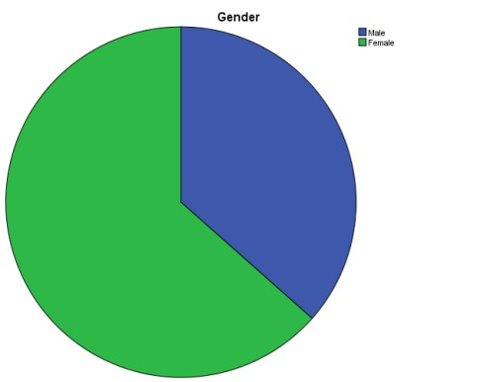

Gender
 |  | Frequency | Percent | Valid Percent | Cumulative Percent
Valid | Male | 19 | 36.5 | 36.5 | 36.5
Valid | Female | 33 | 63.5 | 63.5 | 100.0
 | Total | 52 | 100.0 | 100.0


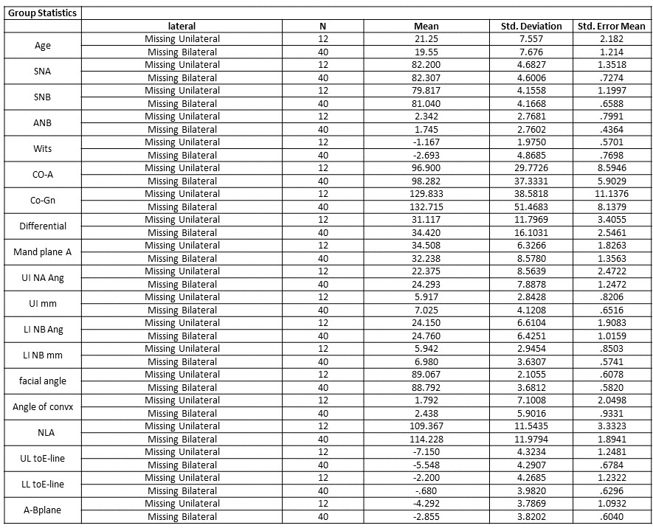
Appendix 2: Independent sample t-test.


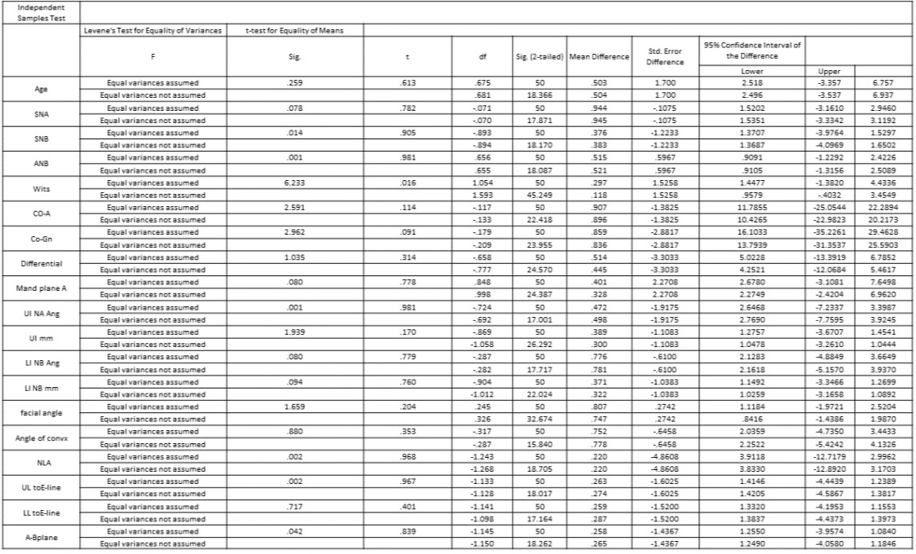
Appendix 3: Independent sample t-test.

Appendix 4: Case summaries.

