APPENDICES

Table A1: Refraction Results of Patient X, March 2021.
Eye | Refraction | Visual Acuity at 20ft | Visual Acuity at 40 cm
OD | -0.25 DS | 20/20 | 20/20
OS | Plano/ -0.50x 85 | 20/20 | 20/20
OU | ----------------------- | 20/20 | 20/20

Table A2: Preliminary tests conducted on Patient X in March, 2021.
Preliminary Test | Findings and Results
Pupillary exam | No Relative Afferent Pupillary Defect
Confrontation Visual Fields | Full and Unrestricted
Intra-Ocular Pressure (Goldmann Applanation) | OD: 12 mmHg  OS: 11mmHg at 10:00 am
Ocular Motility | Smooth, Afferent , Full and Extensive
NPC | To the nose
Cover test (Distance) | Orthophoria and Orthotropic
Cover test ( 40 cm) | Orthophoria and Orthotropic
Colour Vision (Ishihara Plates) | No plates missed
Stereopsis (TNO Butterfly) | 25’’
Pachymetry | OD: 502 microns  OS: 507 microns

Table A3: Preliminary tests conducted on Patient X in July, 2021.
Preliminary Test | Findings and Results
Ocular Complaints after March Visit | Mild Red Eyes in mid June 2021 with no itchy eye sensation. Used Pataday OTC for relief.
Pupillary exam | No Relative Afferent Pupillary Defect; Slow Reaction of Pupils
Confrontation Visual Fields | Restricted on Temporal Gazes  No Pain or Discomfort
Intra-Ocular Pressure (NCT) | OD: 12.5 mmHg  OS: 13 mmHg at 2:30 pm
Ocular Motility | Smooth  No Pain on Eye-Movement
NPC | Constant Diplopia
Cover test (Distance) | Orthophoria and Orthotropic
Cover test (40 cm) | Orthophoria and Orthotropic (Diplopia)
Colour Vision (Ishihara Plates) | 3 Plates missed (Plate 2, 4 and 5)
Stereopsis ( TNO Butterfly) | 200’’
Pachymetry | OD: 502 microns  OS: 507 microns

Table A4: Blood Work Test Results
Sample Received: 05-06-2021 (DD/MM/YEAR)
Blood Work Tests | Results | Reference Range
Creatinine Phosphokinase (CPK) | 294.0 H IU/L | Male(M): 24-190 IU/L  Female(F): 24-170 IU/L
SGOT (AST) | 37 IU/L | M: 0-37  F: 0-31
SGPT (ALT) | 35 IU/L | M: 0-42  F: 0-32
Lactate Dehydrogenase (LDH) | 438 IU/L | 225-450 IU/L
CKMB | 8.4 IU/L | 0-25 IU/L
Troponin 1 | < 0.5…Negative | <0.5 ng/mL
D-Dimer | 269.0 H | 0-255 ng/mL
Ferritin | 79.68 ng/mL | 13.0-349.0 ng/dL
ESR  08/06/2021 | 7 | M: 0-10 mm/hr  F: 0-20mm/hr

Table A5: Heamatology Blood Report.
Sample Received: 05-06-2021 (DD/MM/YEAR)
TEST | RESULTS |  | PATIENT LIMITS
WBC | 10.9 | X 10^3/uL | 4.0-11.0
NEU | 55.8 | % | 40-75
LY | 41.3 | % | 20.0-51.0
MO | 1.19 | % | 1.0-10.0
EOS | 1.55 | % | 1.0-6.0
BASO | 0.18 | % | 0-2
NEU # | 6.08 | X 10^3/uL | 2.5-7.5
LY # | 4.50 | X 10^3/uL | 1.2-3.4
MO # | 0.13 | X 10^3/uL | 0.2-0.8
EOS # | 0.17 | X 10^3/uL | 0.0-0.4
Baso # | 0.02 | X 10^3/uL | 0.0-1.0
RBC | 5.44 | X 10^6/uL | F: 3.9-5.4  M: 4.5- 6.5
Hgb | 16.1 | g/dL | F: 11.5-16.4  M: 13.8-18.0
Hct | 44.6 | % | F: 36.0-47.0  M: 40.0-54.0
MCV | 81.9 | fL | 76.0-96.0
MCH | 29.6 | pg | 27.0-33.0
MCHC | 36.1 | g/dL | 32.0-36.0
RDW | 13.8 | % | 12.9-17.8
Pit | 308. | X 10^3/uL | 150-400
MPV | 8.7 | fL | 7.0-11.0

Ocular and Clinical Observations and Findings: 13 September, 2021

Figure A1: Fransworth D-15 Colour Vision Test (13-09-2021).
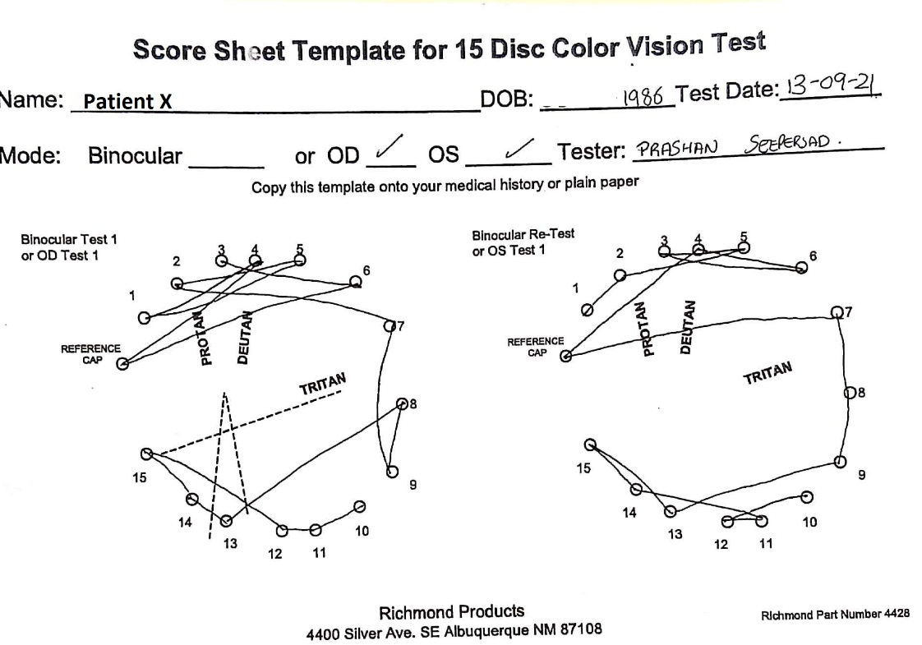

Figure A2: MRI of Brain SAG T1 SE.
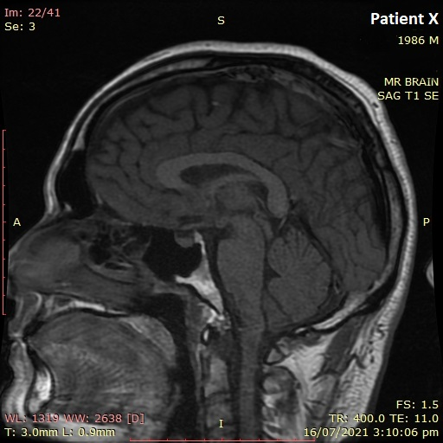

Figure A3: MRI of Brain SAG T1 SE.
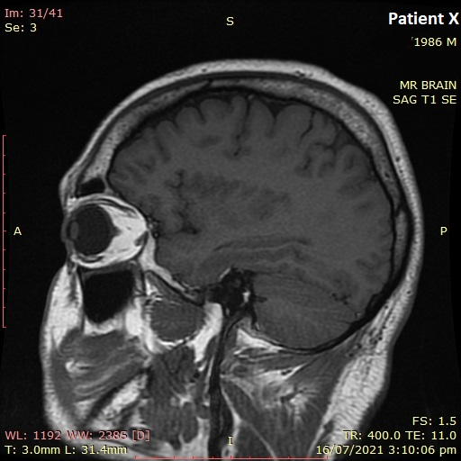
Figure A4: MRI of Brain: Brain Localizer.
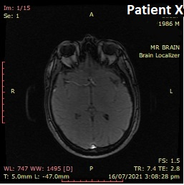

Figure A5: MRI of Brain AX Diffussion.
