Facile DNA detection based on fluorescence switching of a hydrophobic AIE dye-labeled peptide nucleic acid probe by aggregation/disaggregation

Koji Kawamura, Ai Matsumoto and Takashi Murashima*
Faculty of Frontiers of Innovative Research in Science and Technology (FIRST), Konan University, 7-1-20 Minatojima-minamimachi, Chuo-ku, Kobe 650-0047, Japan

Supplementary Information

S1. Materials and instruments
S2. Synthesis of TPE-aldehyde
S3. Synthesis of TPE(CN)-COOH
S4. Synthesis of AIE-PNA with solid-phase synthesis
S5. Figure (fluorescence quenching ratios of 12, 24, 48-mer telomeric DNA)
S6. Fluorescence spectra of AIE-PNA in water and water/ACN mixed solvents

S1. Materials and instruments
All reagents for the synthesis of AIE dye were purchased from Wako Pure Chemical Industries (Osaka, Japan) and Tokyo Chemical Industry Co., Ltd. (Tokyo, Japan), and used without further purification. Fmoc-PNA monomer and coupling agents were purchased from Link Technologies, Ltd. (Bellshill, UK) and Watanabe Chemical Industries, Ltd. (Hiroshima, Japan), respectively. Telomeric DNA and negative control DNA were custom-synthesized by Hokkaido System Science Co. (Hokkaido, Japan). The model sequences chosen for our study were 12, 24, 48-mer human telomeric repeat sequence [5’-(TTA GGG)_{n}-3’, n = 2,4,8], which mimic the telomeric G-rich tail, and the sequence used for the negative control was 5’-(TGA GTG)₂-3’.
Synthetic compounds were identified by ECA-500 NMR spectrometer (JEOL, Japan), ZQ 2000 LCMS (Waters, USA) and MALDI-TOF-MS (Bruker Daltonics, USA). Concentrations of DNA and PNA solution were determined using UVmini-1240 UV-Vis Spectrophotometer (Shimazu, Japan). Fluorescence spectra were measured using RF-5300PC fluorescence spectrometer (Shimazu, Japan). DLS measurement was performed on zetasizer nanoZS (Malvern, UK).

S2. Synthesis of TPE-aldehyde

2-bromo-1,1,2-triphenylethylene (1.84 g, 5.50 mmol), 4-(4,4,5,5-tetramethyl-1,3,2-dioxaborolane-
2-yl)benzaldehyde (1.00 g, 4.32 mmol), K₂CO₃ (2.07 g, 15.0 mmol) and Pd(PPh₃)₄ (145 mg, 0.126 mmol) were added into three-neck flask under N₂, and dissolved in the mixed solvents of deaerated toluene (22 mL) and DMF (8 mL). The solution was stirred for 19 hrs at 85°C. After cooled to room temperature, the reaction solution was passed by silica pad with ethyl acetate. The filtrate was concentrated, and the residue was purified by column chromatography (eluents; CHCl₃/n-hexane = 1/2). The obtained oil was performed the precipitation with MeOH and water. The resulting precipitate was collected by suction filtration, and dried in vacuo. Yield: 79.1% (1.23 g, 3.42 mmol). ¹H-NMR (CDCl₃, 500 MHz): δ (ppm) 9.90 (s, 1H), 7.62 (d, J = 9.0 Hz, 2H), 7.19 (d, J = 8.0 Hz, 2H), 7.13-7.10 (m, 9H), 7.04-7.00 (m, 6H). ¹³C-NMR (CDCl₃, 500 MHz): δ (ppm) 191.93, 150.55, 143.02, 142.97, 142.88, 139.73, 134.23, 131.93, 131.27, 131.22, 129.16, 127.91, 127.73, 127.03, 126.88, 126.85. LCMS: m/z calcd for C₂₇H₂₀O; 360.15, found 361.31 (M+H⁺, 84), 383.29 (M+Na⁺, 100).

S3. Synthesis of TPE(CN)-COOH

TPE-aldehyde (542 mg, 1.50 mmol) was dissolved in EtOH (15 mL). Then, ethyl cyanoacetate (333 mg, 2.94 mmol) and piperidine (0.3 mL) were added to the solution. The mixture was heated to 80°C and stirred for 5 hrs. After 5 hrs, the solvent was evaporated. The residue was purified by column chromatography (eluents; CHCl₃/n-hexane = 1/1). Subsequently, the obtained ester compound was dissolved in EtOH (50 mL) and 1 M NaOH aq. (30 mL), and stirred for 1 hr. After the hydrolysis reaction completed, 1 M HCl aq. (35 mL) was added to the solution. The reaction was extracted with CHCl₃ (washed with distilled water), and evaporated. Crude product was purified by column chromatography (eluents; CHCl₃→CHCl₃/MeOH = 10/1). The obtained product was performed the precipitation with CHCl₃ and n-hexane. The resulting yellow color precipitate was collected by suction filtration, and dried in vacuo. Yield: 50.5% (325 mg, 0.760 mmol). ¹H-NMR (CDCl₃, 500 MHz): δ 8.18 (s, 1H), 7.77 (d, J = 8.5 Hz, 2H), 7.17-7.11 (m, 11H), 7.04-7.00 (m, 6H). ¹³C-NMR (CDCl₃, 500 MHz): δ (ppm) 167.46, 156.21, 150.44, 143.63, 142.94, 142.87, 142.72, 139.52, 132.31, 131.31, 131.30, 131.23, 131.06, 129.03, 128.02, 128.00, 127.73, 127.28, 126.97, 115.25, 100.67. MALDI-TOF-MS: m/z calcd for C₃₀H₂₁NO₂; 427.16, found 428.05 (M+H⁺, 100).

S4. Synthesis of AIE-PNA with solid-phase synthesis
The sequence of AIE-PNA was AIE-Acp(6)-CCC TAA-Acp(6)-K-OH which was modified AIE dye at N-terminus. AIE-PNA was synthesized on Fmoc-Lys(Boc)-Alko-PEG Resin (42 mg, 10 μmol) with Fmoc-solid phase synthesis. Fmoc-Acp(6)-OH and each Fmoc-PNA-OH were 6-fold and 10-fold used for coupling reaction, and dissolved in 702 μL NMP containing 0.15 M HATU, 0.15 M HOBt and 0.3 M DIPEA. Coupling reaction was performed for 1 hr. Deprotection of Fmoc-group was performed for 15 min using 20% piperidine in DMF. Wash of resin between the deprotection and coupling steps was performed for 2 mL×5 with DMF/DCM (1/1). In the case of AIE dye labeling, excess amount of AIE dye (≥10-fold) in NMP containing 0.15 M HATU, 0.15 M HOBt and 0.3 M DIPEA was used. The product was cleaved from the resin and performed the deprotection by treating with 500 μL of TFA/m-cresol/Thioanisole (90/5/5) for 2 hrs. 2 mL of ether was added to the solution, and the resulting precipitate was washed for 2 mL×3 with ether. Crude product was purified by HPLC using 0.1% TFA in water and 0.1% TFA in ACN with monitoring two absorptions at 260 nm and 360 nm. Purified AIE-PNA was dried in vacuo, and stored at -20°C. MALDI-TOF-MS: m/z calcd for C₁₁₁H₁₃₄N₃₈O₂₂; 2351.05, found 2352.91 (M+H⁺, 42), 2374.87 (M+Na⁺, 98), 2390.82 (M+K⁺, 100).

Figure S1: Structure of TPE derivative labeled PNA probe (orange: AIE dye, pink: Linker, blue: PNA, green: Lys)

S5. Figure (fluorescence quenching ratios of 12, 24, 48-mer telomeric DNA)
Fluorescence quenching (FQ) ratio was calculated from below equation (eq.1).

FQ (%) = 100{[FI₅₄₀ (Blank)-FI₅₄₀ (Sample)]/FI₅₄₀ (Blank)} (eq.1)

where FI₅₄₀ (Blank) and FI₅₄₀ (Sample) represent the fluorescence intensity at 540 nm of the absence of telomeric DNA and the presence of 5 μM of telomeric DNA, respectively.

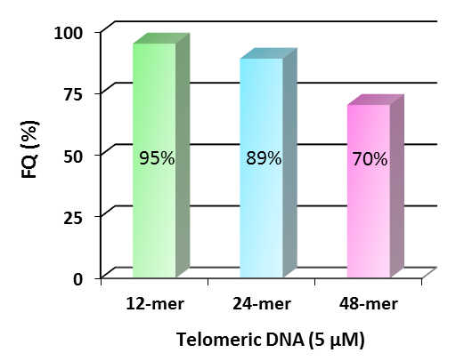
Figure S2: Relationship between fluorescence quenching ratio and telomere length. [PNA probe] = 3 μM, [Telomeric DNA] = 5 μM, 50 mM LiCl and 20 mM tris-HCl buffer (pH 7.5), 25°C.

S6. Fluorescence spectra of AIE-PNA in water and water/ACN mixed solvents
20 μL of 30 μM stock solution of AIE-PNA was added to each solvent as follows; 180 μL MilliQ water (blue), 80 μL MilliQ water/100 μL ACN (50% ACN in MilliQ, green), or 180 μL ACN (90% ACN in MilliQ, red).

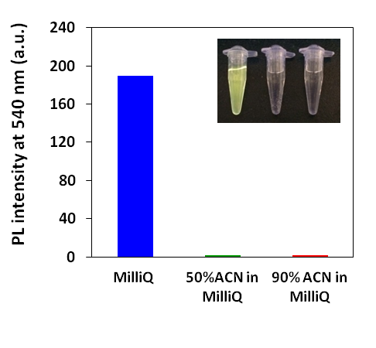
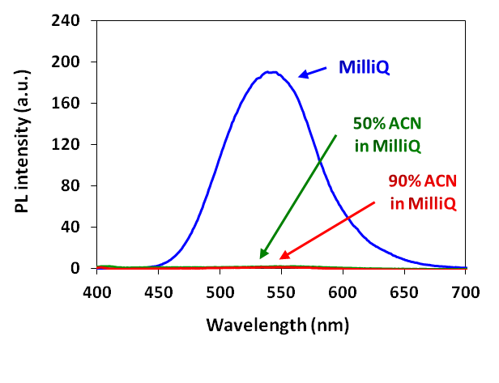

Figure S3: Fluorescence spectra of 3 μM AIE-PNA in each solvent (left) and fluorescence intensity at 540 nm and fluorescence image (left; MilliQ, center; 50% ACN in MilliQ, right; 90% ACN in MilliQ))

