Table 2: Statistical results of peak forces (in body weight) in eight foot regions during jump shot landing.

Region |  | Court | Side |  | Statistical Results
 |  |  |  |  | Side | Court | Interaction
 |  |  | Non-shooting | Shooting | P (η_{p}²) | P (η_{p}²) | P (η_{p}²)
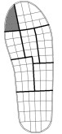 | Hallux | Wood | 0.12 (0.06) | 0.08 (0.04) | 0.073  (0.244) | 0.906  (0.001) | 0.240  (0.113)
 |  | Asphalt | 0.11 (0.07) | 0.09 (0.05)
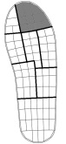 | Lesser toes | Wood | 0.21 (0.10) | 0.22 (0.10) | 0.432  (0.052) | 0.283  (0.095) | 0.782  (0.007)
 |  | Asphalt | 0.18 (0.10) | 0.21 (0.11)
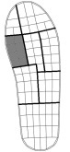 | Medial forefoot | Wood | 0.25 (0.10) | 0.18 (0.09) | 0.039  (0.309) | 0.820  (0.004) | 0.268  (0.111)
 |  | Asphalt | 0.24 (0.10) | 0.20 (0.09)
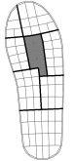 | Central forefoot | Wood | 0.40 (0.11) | 0.34 (0.23) | 0.260  (0.105) | 0.535  (0.033) | 0.673  (0.015)
 |  | Asphalt | 0.36 (0.10) | 0.32 (0.13)
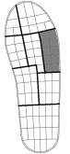 | Lateral forefoot | Wood | 0.23 (0.09) | 0.20 (0.12) | 0.568  (0.028) | 0.580  (0.026) | 0.227  (0.119)
 |  | Asphalt | 0.20 (0.07) | 0.21 (0.11)
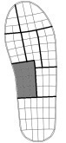 | Medial arch | Wood | 0.07 (0.07) | 0.05 (0.06) | 0.751  (0.015) | 0.185  (0.142) | 0.115  (0.194)
 |  | Asphalt | 0.07 (0.07) | 0.08 (0.10)
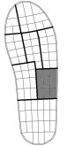 | Lateral arch | Wood | 0.16 (0.10) | 0.10 (0.08) | 0.192  (0.139) | 0.584  (0.026) | 0.091  (0.220)
 |  | Asphalt | 0.15 (0.06) | 0.13 (0.10)
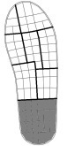 | Heel | Wood | 0.38 (0.24) | 0.23 (0.23) | 0.002  (0.564) | 0.728  (0.010) | 0.957  (< 0.001)
 |  | Asphalt | 0.35 (0.18) | 0.22 (0.17)
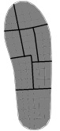 | Total | Wood | 1.30 (0.40) | 1.09 (0.58) | 0.483  (0.042) | 0.834  (0.004) | 0.244  (0.111)
 |  | Asphalt | 1.23 (0.26) | 1.20 (0.53)

Note: Data are expressed in mean (SD). The shooting side was defined as the foot on the same side of the shooting arm (right n = 12, left n = 1). Significant P-values from repeated measures ANOVA (P < 0.05) are shown in bold. Effect size (η_{p}²) values of 0.01, 0.09 and 0.25 were interpreted as small, medium and large effects, respectively.

