Appendix A

SWOT Analysis
Figure 1
SWOT Analysis
Strength
- Appropriate too to assess for depression in the population
- A valid and reliable predictor of depression
- The PHQ-9 is an evidence-based tool.
- Used in clinical practices today.
Weaknesses
- All staff may not be adequately trained
- High turn-over rate at site
- The RN may feel like it is additional work to implement the PHQ-9 tool
- Only an RN and assess and there is only one RN at the clinic.
Opportunities
- Educate staff to ensure an effective use the tool in an unbiased manner
- Assisting provider with developing a treatment plan
- For primary clinic to implement an evidence-based practice project into a practice
- To improve the quality of life for patients that show symptoms of depression
- To save a life from suicide ideations or suicide
Threats
- There is other effective tool available to screen for depression
- Patients see depression as a stigma.
- Patient may not provide open and honest answers on PHQ-9 screening tool
- May not comprehend what question is asking

Appendix B

Literature Evaluation Table
Primary Quantitative Research – Intervention (5 Articles)
APA Reference | Research Questions/ Hypothesis, and Purpose/Aim of Study | Type of Primary Research Design | Research Methodology | Interpretation of Data  (State p-value: acceptable range is p= 0.000 – p= 0.05) | Outcomes/  Key Findings  (Succinctly states all study results applicable to the DPI Project.) | Limitations of Study and Biases | Recommendations for Future Research | Explanation of How the Article Supports Your Proposed Intervention
Aslan, J., Cova, F., Saldivia, S., Bustos, C., Inostrza, C., Rincon, P., Ortiz, P., & Buhring, V. (2020). Psychometric properties in the Patient Health Questionnaire-9 in elderly Chilean primary care users. Frontiers of Psychiatry,11, 1-8 https://doi.org/10.3389/fpsyt.2020.55011 | For the patients in a primary care clinic in Arkansas, will the translation of Pfizer’s Patient Health Questionnaire-9 (PHQ-9) improve the identification of depressive symptoms and subsequent referral to a mental health provider over eight weeks? | Cross sectional design | Patient Healthcare (PHC) Setting, Austria, n=577 participants  PHQ-9 screening tool used.  A Composite International Diagnostic Interview (CIDI), a survey with sociodemographic characteristics and the PHQ-9. | p= <0.001 | PHQ-9 can assist with detecting depression by showing reasonable accuracy in identifying. | The performance of the PHQ-9 was limited by the low prevalence rate of major depressive disorder (MDD) in the target population and the analysis in this study was done contrasting two specific measures over time (MDD and CIDI) and assuming that the use of the CIDI as a gold standard. | In cases above the cut-off point, it is recommended to perform a more thorough evaluation. | The access and validity of the PHQ-9 screening tool. The PHQ-9 has adequate psychometric properties for elderly primary care users.
Levis, B., Benedetti, A., & Thombs, B. (2019). Accuracy of the Patient Health Questionnaire-9 for screening to detect major depression: Individual participant data analysis. British Medical Journal,365, 1-11. https://doi.org/10.1136/bmj.I1476 | To determine the accuracy of the PHQ-9 for screening to detect major depression | Individual participant data meta-analysis | Canada, n=2312  PHQ-9 screening tool.  Fully structured interviews. | p= <0.001 | PHQ-9 can assist with detecting depression by showing reasonable accuracy in identifying | Unable to include primary data from 14 to 69 published eligible datasets and the analyses were restricted to those with complete data for all variables used in various analyses. | Future research should be based on semistructed diagnostic interviews, should consider estimating possibilities of depression across the full spectrum of PHQ-9 screening scores and should combine screening scores with individual characteristics to generate individual probabilities of major depression. | PHQ-9 sensitivity compared with semi structured diagnostic interviews was greater than in previous conventional meta-analyses that combined reference standards.
Molebatsi, K., Motlhatlhedi, K., & Wambua, G. N. (2020). The validity and reliability of the Patient Health Questionnaire-9 for screening depression in primary care patients in Botswana. BioMed Central Psychiatry, 20(295), 1-10. https://doi.org/10.1186/s12888-020-02719-5 | To determine the validity and reliability of the PHQ-9 for screening depression in a primary care population. | Cross sectional design | Primary healthcare setting, Botswana, n=257  PHQ-9 screening tool.  The data was collected from a conveniently selected sample | p= <0.001 | PHQ-9 can assist with detecting depression by showing reasonable accuracy in identifying | Participants were drawn from only two primary care facilities in the capitol of Gaborone which may not be representative of the wider population. | A planned use of the PHQ-9 as a screening tool in a pilot study to evaluate the effects of depression management on glycemic control in noncommunicable diseases in clinics in Malawi. | The PHQ-9 screening tool is a reliable and valid instrument to screen for depression in primary care facilities on Botswana.
Patel, J. S., Med, Y. O., Rand, K. L., Wu, W., Cyders, M. A., Kroenke, K., & Stewart, J. C. (2019). Measurement invariance of the Patient Health Questionnaire-9 depression screener in the United States adults, across, sex, race/ethnicity, and education level. Depression and Anxiety, 36, 813-823. https://doi.org/10.1002/da.22940 | To possess measurement invariance could result in under/over-detection of depression, potentially exacerbating sociodemographic disparities in depression. | Cohort | U.S., n=31,366  The English version of the PHQ-9 screening tool for depression used. | p= <0.001 | PHQ-9 can assist with detecting depression by showing reasonable accuracy in identifying | There are missing values which could limit the generalizability of findings. | Future studies are needed to determine whether measurement invariance of the selected two-factor solution for the PHQ-9 holds over time. | PHQ-9 is acceptable to use in major U.S sociodemographic groups and allows for meaningful comparisons in total, cognitive/affective and somatic depressive symptoms across groups, extending its use to the community.
Shin, C. Ko, H., Yoon, H & Han, C. (2020). Normative data and psychometric properties of the Patient Health Questionnaire-9 in nationally Korean population BMC Psychiatry, 20(194), 1-10. https://doi.org/10.1186/s12888-020-02613-0. | To provide the normative data and psychometric properties of PHQ-9 in the nationally representative population of Korea. | Cross-Sectional design | Korea, n=10759  Health interview questionnaire and the PHQ-9 screening tool | p= <0.001 | PHQ-9 can assist with detecting depression by showing reasonable accuracy in identifying | The characteristics of the sample was a limitation, and the validity of the PHQ-9 was not evaluated with the standard criterion of clinical interviews, which involves the calculation of the specificity and sensitivity for an optimal cut-off point and plotting of a receiver operating characteristics curve. | Suggest that in a nationally representative population, normative data of percentile rank generated using the PHQ-9 are useful for interpreting the severity of depressive symptoms on the PHQ-9. | Results provides evidence that supports its utility as valid and reliable measurement for depression in the general population in Korea.

Additional Primary and Secondary Quantitative Research (10 Articles)
APA Reference | Research Questions/ Hypothesis, and Purpose/Aim of Study | Type of Primary or Secondary Research Design | Research Methodology | Interpretation of Data | Outcomes/  Key Findings | Limitations of Study and Biases | Recommendations for Future Research | Explanation of How the Article Supports Your Proposed DPI Project
Furukawa, T. A., Levine, S., Buntrock, C., Ebert, D. D., Gilbody, S., Brabyn, S., Kessler, D., Bjorkelund, C., Eriksson, M., Kleiboer, A., van Straten, A., Riper, H., Montero-Marin, J., Garcia-Campayo, J., Phillips, R., Schneider, J., Cuipers, P., &Karyotaki, E. (2021). How can we estimate QALYs based on PHQ-9 scores? Equipercentile linking analysis of PHQ-9 and EQ-5D. Evidence Based MentalHealth, 24, 97-101. https://doi.org/10.1136/ebmental-2020-300240. | To construct a conversion table from the Patient Health Questionnaire -9 (PHQ-9) compared to the Euro-Qol Five Dimensions Three Levels | Randomized control trial | N=2,457 participants  PHQ-9 screening tool and the EQ-5D-3L instrument used.  Data was collected by obtaining individual participant data of internet cognitive behavioral therapy. | p= <0.001 | PHQ-9 can assist with detecting depression by showing reasonable accuracy in identifying depression and is a useful screening tool in this setting. | Limited to participants of trials of internet cognitive behavioral therapies (iCBT) and only able to compare the PHQ-9 to Euro-Qol Five Dimensions Three Levels (EQ-5D-3L). | The PHQ-9 and the EQ-5D-3L will need to be linked to examine if similar conversion values can be obtained. | The conversion table of the PHQ-9 will enable fine-grained assessment of burden of depression at its various levels of severity and impacts of its various treatments which may bring various degrees of improvement at the expense of some potential side effects.
Stevens, E., Mazumdar, M., Caniglia, E. C., Khan, M. R., Young, K. E., Edelman, E. J., Gordon, A. J., Fiellin, D. A., Maisto, S. A., Chichetto, N. E., Crystal, S., Gaither, J. R., Justice, A. C., & Braithwaite, R. S. (2020). Insights provided by depression screening regarding pain, anxiety and substance use in veteran population. Journal of Primary Care and Community Health, 11, 1-10. https://doi.org/10.1177/2150132720949123 | To quantify the extent to which a depression screening instrument commonly used in primary care settings provides additional regarding pain interference symptoms, anxiety, and substance use. | Cohort Study | United States, n=7731  PHQ-9 screening tool | p= <0.001 | PHQ-9 can assist with detecting depression by showing reasonable accuracy in identifying | The presence of clustering conditions was assessed using brief screening tools or self-report rather than clinical diagnoses. The study also included veterans receiving care at the VA, an older, racially diverse, lower socioeconomic status population compared to the general US population and a guaranteed access to health care. | Recommend that all positive depression screening results should lead to additional assessment of comorbid psychological factors such as anxiety. | Using information from a positive depression screening results to trigger assessment of conditions expected to cluster together appears to be a promising way to improve case finding and by extension, treatment of anxiety and pain.
Udedi, M. Muula, A.S., Stewart, R.C. & Pence, B.W. (2019). The validity of Patient Health Questionnaire-9 to screen depression in patients with type-2 diabetes mellitus in non-communicable disease clinics in Malawi. BMC Psychiatry,19(8), 1-7. https://doi.org/10.1186/s12888-019-2062-2. | Aim of study was to determine the sensitivity and specificity of the PHQ-9 in the detection of depression among patients with type-2 diabetes mellitus attending a non-communicable disease clinic in Malawi. | Validation Study | Sub-Hararn Africa, n=323 patients  Depression screening tool used (PHQ-9). |  | PHQ-9 can assist with detecting depression by showing reasonable accuracy in identifying depression and is a useful screening tool in this setting. | No limitations of study or bias | A planned use of the PHQ-9 as a screening tool in a pilot study to evaluate the effects of depression management on glycemic control in noncommunicable diseases in clinics in Malawi. | Positive results of PHQ-9 a reliable tool to detect depression in the primary healthcare setting with adults.
Villarreal-Zegarra, D., Copez-Lonzoy, A., Bernabe-Ortiz, A., Melendez-Torrez, G.J. & Bazo-Alveraz, J.C. (2019). Valid group comparisons can be made with the Patient Health Questionnaire-9: a measurement invariance study across groups by demographic characteristics. PLoS ONE, 14(9), 1-15. https://doi.org/  10.1371/journal  pone.0221717. | Analyze the measurement invariance and the factor structure of the Patient Health Questionnaire-9 (PHQ-9) in the Peruvian population. | Cohort Cross Sectional Study | Peruvian, N= 30, 449  Depression screening tool used (PHQ-9) | p= <0.01 | The evidence presents support for the one-dimensional model and measurement invariance of the PHQ-9 measure, allowing for reliable comparisons between sex, age groups, education level, socioeconomic status, marital status, and residence area, and recommends its use within the Peruvian | Two or more participants belonged to the same family. | Recommends it’s use within the Peruvian population. | The PHQ-9 showed consistently good measurement invariance, allowing comparisons between groups by age, sex, educational level, socioeconomic status, marital status, and residence area.
Kondo, K., Antick, J. R., Ayers, C., Kansagara, D., & Chopra, P. (2020). Depression screening tool for patients with kidney failure: A systematic review. Clinical Journal of the American Society of Nephrology, 15(12), 1785-1795. https://doi.org/10.2215/CJN.05540420. | To identify depression screening tools appropriate for patients with kidney failure and to better understand | A systematic review | N=62  Depression screening tool used- PHQ-9 | p= < 0.007  Sensitivity=0.92.  Specificity=0.92 | Future research should target widely used, free tools such as PHQ-9. | Small sample sizes and few studies examining specific tool thresholds. | Future research examining the diagnostic accuracy of depression tools in the U.S. is needed. | Promising evidence for shorter instruments in the public domain such as PHQ-9
Sun, Y., Fu, Z., Bo, Q., Mao, Z., Ma, X. & Wang, C. (2020). The reliability and validity of PHQ-9 in patients with major depressive disorder in psychiatric hospital. BMC Psychiatry, 20(474), 1-7. https://doi.org/ 10.1186/s12888-020-02885-6. | To verify the feasibility of the PHQ-9 in a psychiatric hospital in China for the reliability and validity on patients with major depressive disorders. | Cohort Study | N=109  PHQ-9 screening tool. | p= <0.01 | PHQ-9 had enough discriminant validity for evaluating depression. | Relatively small sample size. | According to domestic research, the PHQ-9 can be used to evaluate the psychological characteristics of patients with depression but is not sensitive to changes in symptoms. It is recommended aspects of the present student should be evaluated by incorporating appropriate study design in the future. | PHQ-9 showed good reliability and validity, and high adaptability for patients with MDD in psychiatric. A simple, effective, and reliable tool. hospital. It is a simple, rapid, effective, and reliable tool for screening and evaluation of the severity of depression performed well.
Janssen, K., Rosielle, D., Wang, O. & Kim, H.J. (2020). The impact of palliative care on quality of life, anxiety, and depression in idiopathic pulmonary fibrosis: A randomized controlled pilot study. Respiratory Research, 21(2), 1-9. https://doi.org/ 10.1186/s12931-019-1266-9. | To determine the feasibility of performing an RCT to determine the effect of structured palliative care in patients with idiopathic pulmonary fibrosis. | Randomized Controlled Trial | University of Minnesota, N=22  PHQ-9 screening tool. | p= <0.008 | An overall improvement of the screening tool over a 6 months period of time. | Single center study on a small number of patients. | Should focus on selection bias of participants. | A significant worsening over the use of the PHQ-9 in 3 months but improved when continuing for 6 months.
Sundeen,E. Powell, W. & Deuell, R. (2020). Leveraging the annual wellness visit to improve rural depression management. Online Journal ofRural Nursing and Health Care,20(1), 6-31.http://dx.doi.org/10.14574/ojrnhc.v20il.602 | To improve the rate of depression screening and management as a component of an annual well visit in rural healthcare settings by 50% in adult Medicare patients. | Case Report Studies | Dallas, TX N= 65  PHQ-9 screening tool used | p= <0.001 | Foundational to consistency to identify and treat depression in a rural healthcare setting. | Utilization of convenience sampling may cause a potential bias. | According to Mabry- Hernandez et al. (2018), implementation and translation research is needed to identify effective processes and workflows to facilitate adherence with USPSTF recommendations in primary care. Routine depression screening is not a new intervention, however, utilizing the Annual Wellness Visit to deliver screening inconsistent manner is an innovative approach. | The PHQ-9 screening tool is foundational to consistently to identify and treat depression toward remission.
Ruckert- Eheberg, I., Lukascheck, K., Brenk-Franz, K. & Straul, B. (2019). Association of adult attachment and suicidal ideation I primary care patients with multiple chronic conditions. Journal of Affective Disorders, 246, 121-125. https://doi.org/ 10.1016/j.jad.20 18.12.029. | To investigate attachment and suicidal ideation in a sample of chronically ill patients aged 50–85 years in Germany. | Cross Sectional Study | Germany, N=207  PHQ-9 and PHQ-7 screening tool used. | p= <0.001 | GPs familiar with attachment types may use their long-time relationship with their patients to intuitively assess patients’ attachment anxiety; in patients with anxious and/or insecure attachment style, GPs should deliberately explore depression and suicidal ideation. | - Suicidal ideation was assessed using a single item only. Single item assessments are associated with misclassification. | In future studies, appropriate tools that can be used by GPs should be examined, e.g. short screening instruments such as the P4- questionnaire. | - Insecure, anxious adult attachment is associated with increased odds of suicidal ideation in middle-aged to elderly, chronically ill primary care patients. Therefore, knowledge about attachment types may help GPs identify patients at risk of suicidal ideation.
Dadfar, Kalibatseva, Z. & Lester, D. (2018). Reliability and validity of the Farsi version of the Patient Health Questionnaie-9 with Iranian psychiatric outpatients. Trends in Psychiatry and Psychotherapy, 40(2), 144-151. https://doi.org/ 10.1590/2237- 6089-0116. | The aim of this study was to examine the psychometric and screening properties for depression of the PHQ-9 in a sample of Iranian psychiatric outpatients. | Cross Sectional Study | Iran, N=130  PHQ-9 screening tool used | p= <0.001 | Findings suggest that the PHQ-9 has a unidimensional structure, good validity and reliability, and is useful and effective in epidemiological and research settings. | Study investigated PHQ- 9 in a sample of non-hospitalized psychiatric patients, not in the community Sample recruitment not random but convenience, meaning these findings cannot be generalized to other samples. Patients not followed to evaluate therapy responses and feedbacks, so the clinical importance of PHQ-9 not investigated. | Future studies should be conducted with diverse populations and different sociodemographic backgrounds. | - An indication of good construct and criterion-related validity. The results of the factor analysis of PHQ-9 items identified and confirmatory factor analysis confirmed a single factor labeled general depression.

Theoretical Framework Aligning to DPI Project
Nursing Theory Selected | APA Reference – Seminal Research References | Explanation for the Nursing Theory Guides the Practice Aspect of the DPI Project
Jean Watson’s Human Caring | Watson, J. (2008). From CARATIVE FACTOR 4: Developing a Helping-Trusting Relationship to CARITAS PROCESS 4: Developing and Sustaining a Helping-Trusting Caring Relationship. In Nursing: The Philosophy and Science of Caring, 71-76. Revised Edition. University Press of Colorado. http://www.jstor.org/stable/j.ctt1d8h9wn.13  Taylor, R.L. & Watson, J. (1989) They shall not hurt. Boulder,CO: Colorado Associated University Press. | Being authentically present and practicing love and kindness can yield a positive report with your client and patient will feel comfortable and tend to share more of their personal thoughts and concerns.  Attempting to assist patients and health care workers to aim toward cooperation and harmony in everyday living.
Change Theory Selected | APA Reference - Seminal Research References | Explanation for How the Change Theory Outlines the Strategies for Implementing the Proposed Intervention
Kurt Lewin Change Theory | Lewin, K. (1947). Frontier in group dynamics: Concepts, methods and reality in social science, social equilibria and social change. HumanRelations, 1(1), 5-41. https://doi.org/10.1177/001872674700100103  Lewin, K. (1975). Field theory in social science. Westport Connecticut: Greenwood Press. | Lewin’s model of change consists of three steps: Unfreeze- finding a gap within the organization that need change. Moving is when the change has been identified and now moving in the direction of changing the atmosphere within the organization and Refreezing is to bring about permanent change of the new situation (Lewin, 1975).

Appendix C

Project Timeline
Activity | Course | Start Date | Number of Days Required | End Date | Comments
EBP Question:
Conceptual Review of PICOT-D Question | 815A | Date Reviewed:  6-17-21 | 21 days | 7-8-21 | Completed
PICOT-D Question Approved | 820A | Date Approved  8/30/21 | 21 days | Approved | Completed  Approved by Dr. Shay Schroetter
Evidence:
Primary Quantitative Research of the Intervention | 820A | 8-18-21 | 20 days | 9-7-21 | Completed
Additional Primary and Secondary Quantitative Research | 820A | 8-18-21 | 20 days | 9-7-21 | Completed
Connecting Nursing Theory and Evidence-Based Change Model | DNP 820A | 8-24-21 | 7 | 9-1-21 | Completed
Literature Synthesis for Proposed Intervention | DNP 820A | 8-24-21 | 7 | 9-1-21 | Completed
Translation:
Create a project implementation plan (10 Strategic Points) | DNP 820A | 10-21-21 | 56 | 12-1-21 | Completed
Determine fit, feasibility, and appropriateness of the intervention for translation path (DPI Project Budget and Timeline) | DNP 840A | 10-21-21 | 7 days | 2-23-22 | Completed
Project Planning
Attend Virtual Nurse Residency | DNP 930A | Date Attended:  pending | N/A | N/A | Completed
Create a Data Collection Sheet and Data Dictionary | DNP 830A | 4-4-22 | 56 | 6-1-22 | Completed
DPI Project Proposal (Chapters 1-3) | DNP 955A | 6-2-22 | 56 | 9-21-22 | Completed
Proposal (Chapters 1-3) Defense | DNP 955A | 6-2-22 | 56 | 9-21-22 | Completed
IRB Site Authorization for the Project (not MOU) | DNP 955A | 6-2-22 | 56 | 9-21-22 | Completed
Permissions for Tools, Instruments, Surveys or Guidelines | DNP 955A | 6-2-22 | 56 | 9-21-22 | Completed
Project Site IRB Approval/  Determination (if applicable) | N/A | N/A | N/A | N/A | IRB Site approval
GCU IRB Approval | DNP 955A | 6-2-22 | 56 | 9-21-22 | IRB Site Approval
Project Implementation
Implement Project Plan (Training of Staff) | DNP 960A | 9-22-22 | 112 | 1-18-23 | Completed
Collect Data | DNP 960A | 9-22-22 | 112 | 1-18-23 | Completed
Project Evaluation
Evaluate Outcomes (Data Analysis and Results) | DNP 965A | 1-19-23 | 112 | 5-10-23 | Completed
DPI Completed Project (Chapters 1-5) | DNP 965A | 1-19-23 | 112 | 5-10-23 | Completed
Project Dissemination
Report Outcomes to Stakeholders (DPI Final Project Defense) | DNP 965A | 1-19-23 | 112 | 5-10-23 | Future in course
Department Review | DNP 965A | 1-19-23 | 112 | 5-10-23 | Future in course
Dean’s Signature | DNP 965A | 1-19-23 | 112 | 5-10-23 | Future in course
Publish in ProQuest | DNP 965A | 1-19-23 | 112 | 5-10-23 | Future in course

Appendix D

Plan for Educational Offering
OBJECTIVES | CONTENT (Topics) | TEACHING METHODS | TIMEFRAME | EVALUATION METHOD
1. Recall the rationale for implementation of the Patient Health Questionnaire-9 (PHQ-9)/ | Introduction to the evidence behind the implementation of the procedure | Didactic / PowerPoint | Total time  10 minutes | Staffing/group discussion  Pre/post-test questions
2. Provide staff/group training on the PHQ-9 screening tool to increase awareness for the need for the tool, skills, screening, and early detection. | Presentation of protocol and list of commonly identified symptoms of depression with a review of protocol and policy | Group Discussion / PowerPoint | Total time  10 minutes | Staffing/group discussion  Pre/post-test questions:
3. Understand the fundamentals levels of depression based on the PHQ-9 depression scale. | Presentation of protocol and list of commonly identified symptoms of depression with a review of protocol and policy | PowerPoint presentation | Total time  10 minutes | Evaluation through teach-back after in-service with staff/group  Pre/post-test questions
Differentiate the levels of depression based on the PHQ-9 scale. | Presentation of protocol and list of commonly identified symptoms of depression with a review of protocol and policy | PowerPoint presentation | Total time  10 minutes | Teach-back during the staff/group discussion  Pre/post-test questions
5. Summarize the steps to process for the PHQ-9 in the adult population upon check-in. | Presentation of protocol and list of commonly identified symptoms of depression with a review of protocol and policy | PowerPoint presentation | Total time  30 minutes | Teach-back during the hands-on staff/group discussion  Pre/post-test questions
6. Demonstrate the ability to successfully read and comprehend the nurse to patient dialogue | Written information to validate the PHQ-9 screening scale | Written information and power point presentation | 30 seconds | Feedback and teach back method

Appendix E

Grand Canyon University Institutional Review Board Outcome Letter
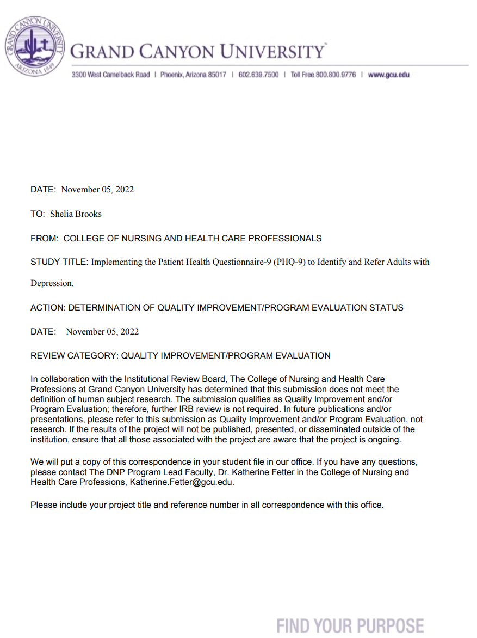

Appendix F

Project Budget
Expenses | Direct or Indirect Cost | Fixed or Variable Cost | Total Anticipated Cost | Rationale for Total Anticipated Cost  (50-150 words each)
Labor:  Nurse Practitioner-$75/hr.  Registered Nurses-$50/hr.  LPN- $20/hr.  Medical Assistant- $15/hr | Indirect | Variable | $320 | The estimated cost for a seminar to introduce the specific details to the APRN, RN, LPN & Medical Asst to train on how to use PHQ-9 tool and how to interpret results for x 2 days for 1 hour.
Materials:  Legal pads- 5 @ 2  Clipboards- 5 @ $2  Pens- 2 pkg @$2  Pamphlets- 50 @ $2  Markers- 5 @ $3  Filing Cabinet- 1@ 50  Flash drive- 2 @ 15  PHQ-9 Forms- free. | Direct | Variable | $219 | For the PHQ-9 in-service the material listed for each employee for in-service. Each employee will have their own set of materials.
Travel: N/A | N/A | N/A | N/A | N/A
Equipment:  Computer | Indirect | N/A | N/A | N/A
Space:  Clinic break room | Direct | N/A | N/A | N/A
License:  RN  LPN  Medical Assistant | N/A | N/A | N/A | No licensurepaid from budget. All employees current on licensures.
Miscellaneous Expense: Statistician  Patient Health Questionnaire Form | Direct  Direct | Variable  Variable | $500  $12.50 | A statistician at $60.00/hr for expertise and consultation for DPI project.  25 cents per copy of PHQ-9 forms for 50 copies.

Appendix G

Patient Health Questionnaire-9
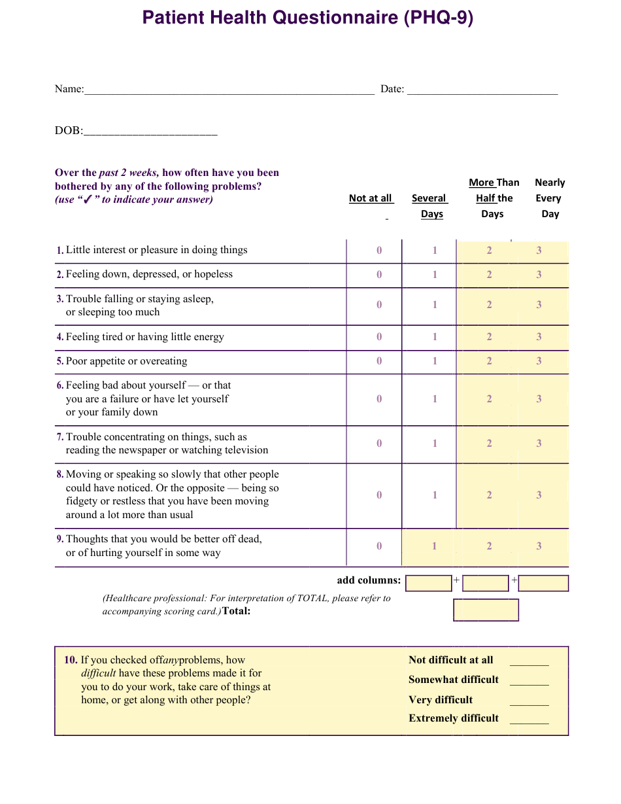

Appendix H

Permission to Use the Patient Health Questionnaire-9
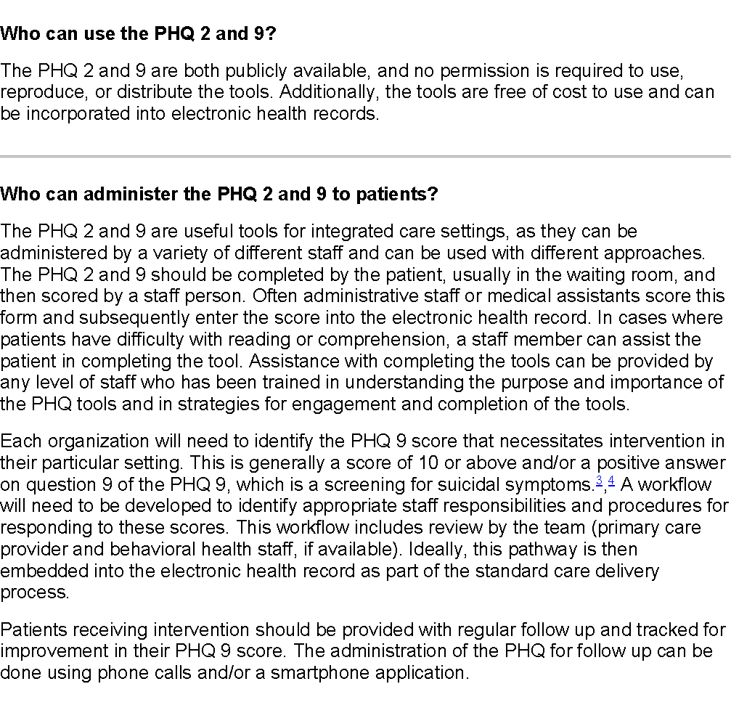

Appendix I

Supporting Literature
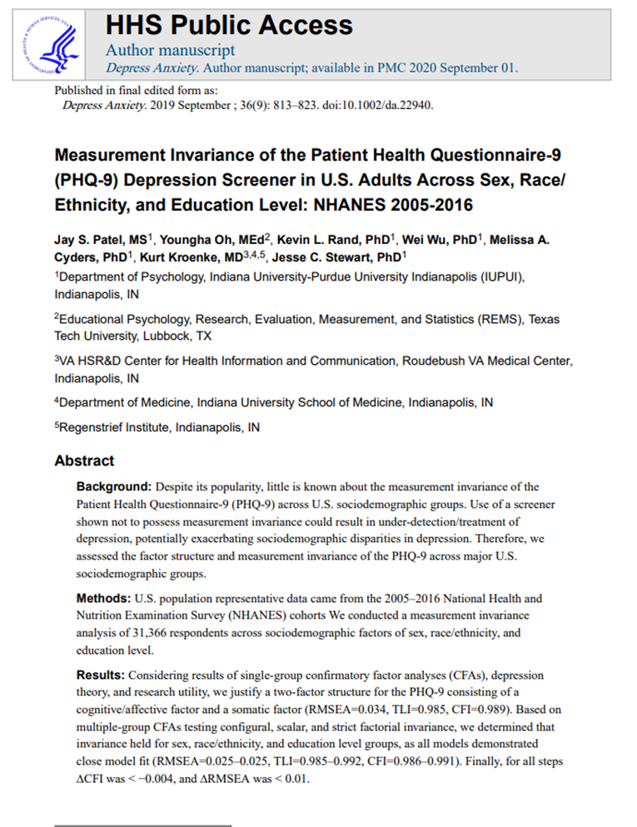
Patel, J. S., Oh, Y., Rand, K. L., Wu, W., Cyders, M. A., Kroenke, K., & Stewart, J. C. (2019). Measurement invariance of the Patient Health Questionnaire-9 depression screener in the United States adults, across, sex, race/ethnicity, and education level. Depression and Anxiety, 36, 813-823. https://doi.org/10.1002/da.22940

