Table 2: Nimotuzumab toxicity. General profile of toxicity in the clinical study by patients and adverse events.

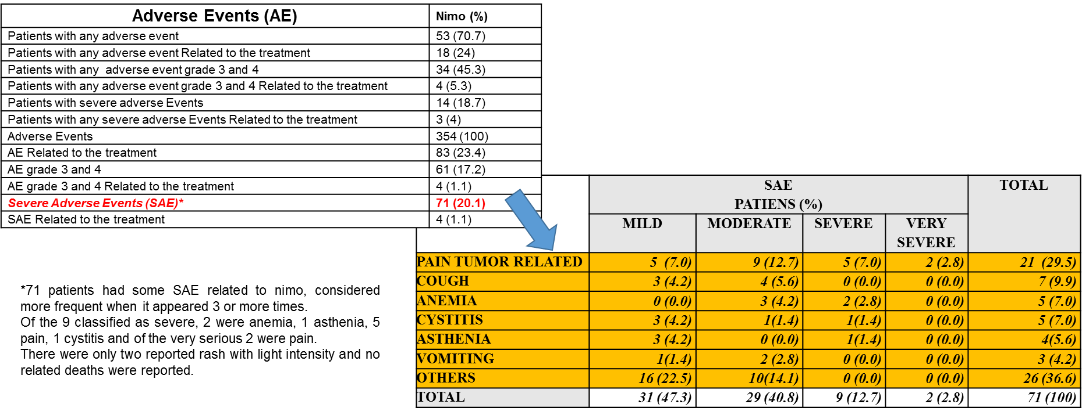

Content
Adverse Events (AE) | Nimo (%)
Patients with any adverse event | 53 (70.7)
Patients with any adverse Related to the treatment | 18 (24)
Patients with any adverse event grade 3 and 4 | 34 (45.3)
Patients with any adverse event grade 3 and 4 Related to the treatment | 4 (5.3)
Patients with severe adverse Events | 14 (18.7)
Patients with any severe adverse Events Related to the treatment | 3 (4)
Adverse Events | 354 (100)
AE Related to the treatment | 83 (23.4)
AE grade 3 and 4 | 61 (17.2)
AE grade 3 and 4 Related to the treatment | 4 (1.1)
Severe Adverse Events (SAE)* | 71 (20.1)
SAE Related to the treatment | 4 (1.1)

*71 patients had some SAE related to nimo, considered more frequent when it appeared 3 or more times.
Of the 9 classified as severe, 2 were anemia, 1 asthenia, 5 pains, 1 cystitis and of the very serious 2 were pain.
There were only two reported rash with light intensity and no related deaths were reporte
 | SAE Patients (%) |  |  |  | Total
 | MILD | MODERATE | SEVERE | VERY SEVERE
PAIN TUMOR RELATED | 5 (7.0) | 9 (12.7) | 5 (7.0) | 2 (2.8) | 21 (29.5)
COUGH | 3 (4.2) | 4 (5.6) | 0 (0.0) | 0 (0.0) | 7 (9.9)
ANEMIA | 0 (0.0) | 3 (4.2) | 2 (2.8) | 0 (0.0) | 5 (7.0)
CYSTITIS | 3 (4.2) | 1 (1.4) | 1 (1.4) | 0 (0.0) | 5 (7.0)
ASTHENIA | 3 (4.2) | 0 (0.0) | 1 (1.4) | 0 (0.0) | 4 (5.6)
VOMITING | 1 (1.4) | 2 (2.8) | 0 (0.0) | 0 (0.0) | 3 (4.2)
OTHERS | 16 (22.5) | 10 (14.1) | 0 (0.0) | 0 (0.0) | 26 (36.6)
TOTAL | 31 (47.3) | 29 (40.8) | 9 (12.7) | 2 (2.8) | 71 (100)

