Based on the 2013 ACC/AHA Guideline on the Assessment of Cardiovascular Risk and the 2013 ACC/AHA Guideline on the Treatment of Blood Cholesterol to Reduce Atherosclerotic Cardiovascular Risk in Adults. This Risk Estimator enables health care providers estimate 10-year and lifetime risks for atherosclerotic cardiovascular disease (ASCVD), defined as coronary death or nonfatal myocardial infarction, or fatal or nonfatal stroke, based on the Pooled Cohort Equations and lifetime risk prediction tools.
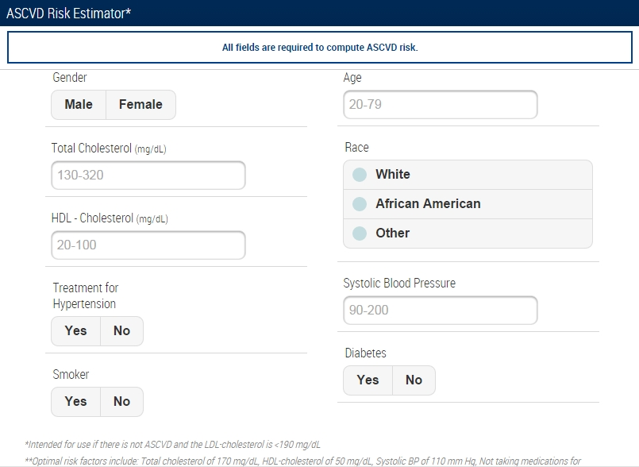 | 1  The assigned nurse will Calculate the diabetic patient ASCVD 10 years Risk using the AHA/ACC calculator online, on a smart phone or using the excel file.

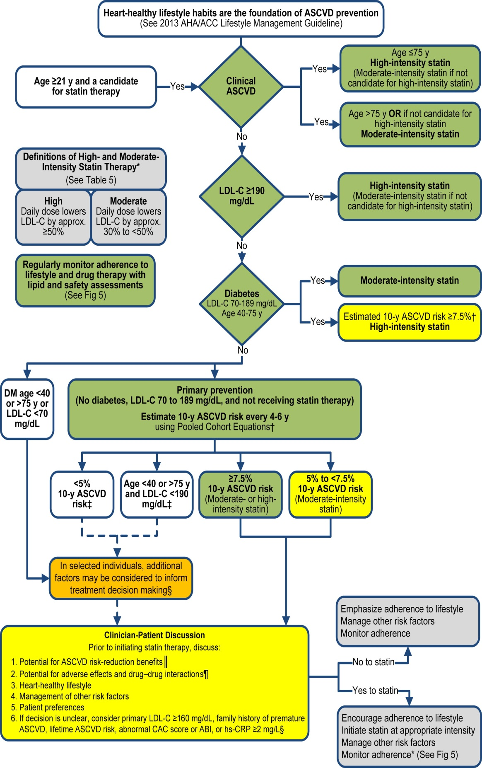 | 2  Interpret the patient’s ASCVD 10 years risk score and/or Lipid profile results to know the management plan for the patient.

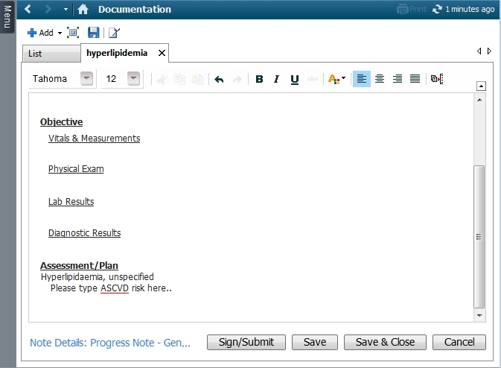  Type here the ASCVD 10 years risk score and your management plan | 3  Document the patient’s ASCVD 10 years risk score in the Assessment and Plan section of your SOAP Notes in CERNER

Intensities of Statin Therapy

High-Intensity Statin
Daily dose lowers LDL-C, on average by approximately ≥50%
- Atorvastatin 40*-80 mg
- Rosuvastatin 20-(40) mg

Moderate-Intensity Statin
Daily dose lowers LDL-C, on average by approximately 30% to <50%
- Atorvastatin 10-(20) mg
- Fluvastatin 40 mg bid
- Fluvastatin XL 80 mg
- Lovastatin 40 mg
- Pitavastatin 2-4 mg
- Pravastatin 40-(80) mg
- Rosuvastatin (5)-10 mg
- Simvastatin 20-40 mg**

Low-Intensity Statin
Daily dose lowers LDL-C, on average by approximately <30%
- Fluvastatin 20-40 mg
- Lovastatin 20 mg
- Simvastatin 10 mg
- Pitavastatin 1 mg
- Pravastatin 10-20 mg

